***Mendit: An ML based web platform to mediate employers and employees (unskilled as well as skilled)***

*Submitted in partial fulfillment of the requirements for the degree of*

Bachelor of Technology

in

**Computer science engineering and CSE with specialization in information security**

*by*

## TEAM NAME: Team MendIT

|  |  |
| --- | --- |
| **Name:** | **Registration Number:** |
| **Manan Sharma (Team leader)** | **18BCI0132** |
| **Hrithik Ahuja** | **18BCE2154** |
| **Rohan Allen** | **18BCI0247** |
| **Rakshith Sachdev** | **18BCI0109** |
| **Ayush Rana** | **18BCE2305** |

## Under the guidance of Prof. Jose S.

**SMEC VIT, Vellore.**



May, 2021

**DECLARATION**

I hereby declare that the thesis entitled “***Mendit: An ML based web platform to mediate employers and employees (unskilled as well as skilled)***

“submitted by me, for the award of the degree of *Bachelor of Technology in Computer science and engineering with specialization in information security* to VIT is a record of bonafide work carried out by me under the supervision of Prof. Jose S.

I further declare that the work reported in this thesis has not been submitted and will not be submitted, either in part or in full, for the award of any other degree or diploma in this institute or any other institute or university.

Place : Vellore Date :27/5/21

Manan Sharma (18BCI0132)

**Signature of the Candidate**

### CERTIFICATE

This is to certify that the thesis entitled “***Mendit: An ML based web platform to mediate employers and employees (unskilled as well as skilled)***

” submitted by **Manan Sharma 18BCI0132**, **SCOPE**, VIT, for the award of the degree of *Bachelor of Technology in Computer science and engineering with specialization in information security*, is a record of bonafide work carried out by him / her under my supervision during the period, 01. 02. 2021 to 31.05.2021, as per the VIT code of academic and research ethics.

The contents of this report have not been submitted and will not be submitted either in part or in full, for the award of any other degree or diploma in this institute or any other institute or university. The thesis fulfills the requirements and regulations of the University and in my opinion meets the necessary standards for submission.

Place : Vellore

Date :27/5/21 **Prof. Jose S.**

**Prof. Jose S.**

**Internal Examiner**

## ACKNOWLEDGEMENTS

I would like to extend my sincere gratitude to my academic advisor, Prof. Jose S for his motivation, support and constant guidance throughout the development of this project. I truly appreciate the trust he has placed in me. I am thankful for their aspiring guidance, invaluably constructive criticism and friendly advice during the project work. I would also like to thank the web resources, open-source tools, family, researchers, School SCOPE, friends and VIT-Business School for the help they provided during the research and development of this company.

**MANAN SHARMA (18BCI0132)**

**Student Name**

# Executive Summary

In daily life, a layman deals with different transaction in terms of selling and purchasing of goods and services. In these transactions the second one persuades the first person. Therefore, selling may be defined as persuading people to satisfy the want of first one. The person, who does this act, is called as the salesman, the result of this action as sales, while these activities of the person, are supervised and controlled by sales-management. In the present scenario sales executives are professionals. They plan, build and maintain effective organizations and design and utilize efficient control procedures. The professionals approach requires thorough analysis, market-efficient qualitative and quantitative personal-selling strategy. It calls for skillful application of organizational principles to the conduct of sales operations. In addition, the professional approach demands the ability to install, operate, and use control procedures appropriate to the firm’s situation and its objectives. Executives capable of applying the professional approach to sales management are in high demand today. The quality of selling is referred to as salesmanship. In other words, ‘management’ is synonymous with leadership. Managers do the same thing in industry, as ministers do in states and at the center, i.e., they have to plan, forecast, direct and control their personnel. Here success lies in running together, hand in hand. Managers are the captains of the army of their followers.

**CONTENTS Page**

**No.**

**Acknowledgement** i

Executive Summary ii

Table of Contents iii

List of Figures ix

List of Tables xiv

1. INTRODUCTION 10
   1. Objective 10
   2. Motivation 10
   3. Literature survey 10
2. METHODOLOGY AND PLAN 18
3. DIGITAL MARKETING PLAN AND RESULTS 19
4. INTERVIEW WITH EXPERTS AND FAMILY 25
5. **DESIGN APPROACH AND DETAILS 29**.
   1. Design Approach and business plan 31
   2. Requirement analysis 38.
   3. Logo design and survey results 45.
   4. Usability testing of GUI and report 51
6. **NESSACARY PERMISSIONS AND LEGAL ASPECTS 56**.
7. **PROJECT DEMONSTRATION 64**.
8. **COST ANALYSIS 67**
9. **RESULT & DISCUSSIONS 67**.

|  |  |  |
| --- | --- | --- |
| 10 | **PROSPECTIVE CUSTOMERS AND FUTURE PLAN** | 70. |
| 11  12 | **REFERENCES**  **SCHEDULES AND ROADMAP** | 70. |

### List of Figures

|  |  |
| --- | --- |
| **Figure No.** | **Title** |
| 1. | **Market survey using google forms.** |
| 2.  3.  4.  5.  6.  7.  8.  9.  10.  11.  12.  13.  14.  15.  16.  17.  18. | **Survey on fakebook and WhatsApp.**  **Facebook story upload responses about the marketing of our team Startup.**  **layered architecture of our system.**  **Functional architecture of our web portal.**  **High level schema for our system**  **UML use case model for the requirements of our system.**  **Low level detailed database schema for the project.**  **The first logo designed by our team.**  **the second logo designed for our web portal by our team.**  **the WhatsApp story and status updates and the following are the responses.**  **the story update on my Facebook platform about our team MendIT’s logo.**  **the questions and the options of the google form survey.**  **the chart and the analysis of the responses from the google forms.**  **Chosen logo by our team.**  **Usability test form of GUI and responses.**  **Gantt chart and activity roadmap for first phase.**  **Gantt chart and roadmap for phase 2 of project.** |

### List of Tables

**Table No. Title Page No.**

1. **Business model for our proposal. 30**
2. **Testing report of modules. 50**
3. **Cost analysis and estimation for our project. 64**
4. **Contribution of individuals. 74**

### INTRODUCTION

* 1. OBJECTIVE
* Providing a medium to common people to easily search and hire workers in their locality within an optimization between user’s budget vs skill of workers and handymen services.
* Provide a platform and a resourceful medium to workers who aren’t able to find regular work in their locality itself, with contract-based or part time jobs as an additional source of income.
  1. MOTIVATION

In daily life, a layman deals with different transaction in terms of selling and purchasing of goods and services. In these transactions the second one persuades the first person. Therefore, selling may be defined as persuading people to satisfy the want of first one. The person, who does this act, is called as the salesman, the result of this action as sales, while these activities of the person, are supervised and controlled by sales-management. In the present scenario sales executives are professionals. They plan, build and maintain effective organizations and design and utilize efficient control procedures. The professionals approach requires thorough analysis, market-efficient qualitative and quantitative personal-selling strategy. It calls for skilful application of organizational principles to the conduct of sales operations. In addition, the professional approach demands the ability to install, operate, and use control procedures appropriate to the firm’s situation and its objectives. Executives capable of applying the professional approach to sales management are in high demand today. The quality of selling is referred to as salesmanship. In other words, ‘management’ is synonymous with leadership. Managers do the same thing in industry, as ministers do in states and at the center, i.e., they have to plan, forecast, direct and control their personnel. Here success lies in running together, hand in hand. Managers are the captains of the army of their followers. This web application hence will help us mediating between employers and employees.

* 1. RELATED WORKS AND SURVEY

Jyoti V Gautam et al. proposed that scheduling problem has been an active area of research in computing systems since their inception.

The Apache Hadoop framework has emerged as most widely adopted framework for distributed data processing because of open source and allowing use of commodity hardware. Job scheduling has become an important factor to achieve high performance in Hadoop cluster. Several scheduling algorithms have been developed for Hadoop-MapReduce model which vary widely in design and behaviour, handling different issues such as locality of data, user share fairness and resource awareness. This paper highlights fundamental issues in job scheduling, presents classification of Hadoop schedulers, and discusses presented survey of existing scheduling algorithm. Moreover, paper also discusses features, advantages, and limitations of the scheduling algorithms. This paper also discusses about how various resource monitoring tools or frameworks help in achieving better result from MapReduce. It also discusses customized MapReduce frameworks used for improving the performance. This paper would be useful to beginners and researchers for understanding the state-of-the-art on scheduling in Big data processing [1].

Dorothea Calmels proposed that the job sequencing and tool switching problem is a combinatorial optimisation problem that appears in various industries, mainly in the manufacturing sector. Although tool switching is only part of a much larger decision-making process in manufacturing systems, it has a major impact on the overall performance of the system by affecting the total set-up time as well as the machine and tool utilisation. Over the past few decades, various approaches have been applied to tool switching problems. This study provides a comprehensive review of the literature on the job sequencing and tool switching problem. Studies are identified and compared through a structured literature review and classified according to a new framework which allows the identification of problem perspectives and solution methods. The results show that current research does not fully exploit real-world situations and studies are often limited to a single-machine and uniform tool size and set-up time. Finally, this literature review summarises the current research results and provides directions for future research [2].

S. Clyde, Jianping Zhang and Chih-Chung Yao proposed in their article that it is challenging to automate job classification due to the many dynamic classes and features, concept drip, uncertainty, and noisy data. This paper presents a solution to this problem by combining an incremental learning subsystem with a job classifier. The authors describe our design and implementation using a complete object-oriented approach known as Object Oriented Systems Modelling (OSM) that uses a smooth mapping to most object-oriented programming languages. The software being written in C++ is performing better than other learning/classification algorithms in experimentation. The production version is performing very accurately [3].

F. M. Javed Mehedi Shamrat et al. proposed that jobseekers tend to register themselves in many job portals and find various job circulars through different sources. Since all job circulars are posted, it is easy to find one that interests them. In addition, these job portals collect information on those who are applying for jobs through these portals. When a new job advertisement is posted on the portal, job seekers receive an email notification. Using a decision tree algorithm, email notification becomes more relevant and personalized for job-seekers. This decision tree is used to analyse job seekers' fields of interest, expected salaries, and experience to make decisions on which job circular should be advertised to which job seekers. It makes the recruitment process more engaging for jobseekers and helps them relate to the notification [4].

L. Xu et al. proposed that there has been substantial attention paid to resource prediction in cloud computing jobs (e.g., CPU/memory usage). Existing models predict jobs utilizing regression techniques based on job historical data under the impractical assumption that the new jobs will be of the same class as the historical ones. This problem can be overcome by taking into consideration the job category for effective resource prediction. A number of existing works on job classification ignore or use a very naive idea of resource consumption variability, leading to unsatisfactory classification accuracy and slow running time. In this paper, the authors introduce a new and efficient job classification approach, called Bejo. Taking inspiration from the textual classification methods which classify documents according to distribution of the textual words, Bejo treats each job as a document. This distribution of "resource words" describes and categorizes a job based on how each snapshot data is assigned to a certain resource word during collection. In order to address the unique challenges of high noise and tight time budget of cloud job classification, an E1 norm minimization formulation is used to assign each resource snapshot to a resource word. A comprehensive dataset is collected for jobs classification and resource consumption prediction on cloud platforms, and Bejo outperforms state-of-the-art algorithms in quality and efficiency. Experimental work also indicates that by adding an additional class of job to the existing regression method, the relative error on resource consumption can be dramatically reduced. [5]. Habiba, Sultana Umme et al. proposed that lately, because of headway in present day innovation and social correspondence, publicizing new position posts has become basic issue in the current world. In this way, counterfeit work posting forecast task will be an extraordinary worry for all. Like numerous other grouping undertakings, counterfeit occupation presenting expectation leaves a part of difficulties to confront. This paper proposed to utilize distinctive information mining strategies and grouping calculation like KNN, choice tree, uphold vector machine, innocent bayes classifier, arbitrary woodland classifier, multilayer perceptron and profound neural organization to anticipate a task post on the off chance that it is genuine or deceitful.

We have tested on Employment Scam Aegean Dataset (EMSCAD) containing 18000 examples. Profound neural organization as a classifier, performs incredible for this grouping task. We have utilized three thick layers for this profound neural organization classifier. The prepared classifier shows around 98% grouping exactness (DNN) to foresee a deceitful occupation post [6].

S. Deshmukh et al. proposed that Hadoop MapReduce is perhaps the most mainstream freely accessible systems for enormous information preparing in the cloud climate. Hadoop accommodates the requirements of a wide assortment of potential clients yet doesn't give a way to upgrade the scheduler for singular clients. This is the thing that we have endeavored to do. The MapReduce planning framework comprises of a single Job Tracker per bunch and various Task Trackers. One of the essential obligations of the work tracker is to plan all the client occupations which makes upgrading the planning by the Job Tracker an intriguing issue. For an improved booking structure, we have actualized booking which likewise takes into account the real asset necessities of the work, as restricted to depending totally on number of free Map and Lessen openings. In this paper, an endeavor is made to make a scheduler that can learn and adjust to any conceivable application. The scheduler orders the errands to be appointed into two classes, schedulable and non-schedulable. This cycle weeds out positions that are probably not going to run on a hub utilizing a cycle that is computationally modest. The experimentation result identifies the work which will over-burden a specific hub and demonstrate the equivalent to the scheduler. Hence, in the event that it is exceptionally impossible that a task will effectively run on a specific hub, that work will be delegated non-schedulable and not be considered for execution on that hub. This will keep occupations from executing somewhat, at that point coming up short also, being rescheduled [7].

A. D. Hartanto et al. proposed that the human asset staff in an organization is an individual in charge of finding new laborers. To get a certified new labour force, a human asset staff should be particular toward the machine regarding capacity and character. This investigation gives an elective point of view to a human asset in getting one's character information through their tweets on a Twitter account. This investigation utilizes the Naive Bayes Classifier calculation with W-IDF (Weighted-Inverse Document Frequency) weighting to order the character of enlisted people into one of Plate's character speculations, in particular Dominance, Influence, Dauntlessness, and Compliance. By utilizing preparing information and test information upwards of 120 individual Twitter records and marking of words that have been confirmed by analysts, gotten character circulation. The order of the tweet information is Predominance 90 records, Influence 10 records, Steadiness 8 records and Compliance 12 records. Assessment of the precision level of 36.67% [8].

Ikudo, Akina & Lane et al. proposed that portraying individuals' occupations is significant for both arrangement and examination. Nonetheless, as huge scope regulatory records are progressively being utilized to portray work market movement, it will get essential to discover new mechanized ways to deal with depicting occupations. We apply new AI strategies to new wellsprings of information and research the capability of utilizing calculations to order occupations. We secure that position titles are both characteristically uproarious and conflicting across associations, however a subset of them can be allotted algorithmically, with little effect on precision [9].

These days, the main objective of students in universities has become acquiring knowledge and specific job skills. Knowledge relating to a specific situation is extremely essential to make informed decisions and therefore, knowledge management in any organization is quintessential in staying one step ahead of the competition in today’s tough and globalized world. In this paper, the authors have come up with the design of an online recruitment system, that enables employers to post their job ads and allows job seekers to interact with the aforementioned employers to secure jobs. This portal captures job requirements based on the industry’s requirements [10].

The present study utilizes VirtuаlBоx virtuаl envirоnment teсhnоlоgy tо develор the personal аnd соmрасt size оf multi- nоde big dаtа VM рlаtfоrm with Sраrk аnd Hаdоор сluster thаt саn effeсtively reрliсаte аnd рrоvides аn envirоnment fоr develорers tо eаsily design аnd imрlement Sраrk аnd Hаdоор Mар/Reduсe programming. By using the multi-nоde Hаdоор VM system, develорers саn соnduсt Mар/Reduсe рrоgrаming соmрletely the sаme аs thаt in the reаl multi-nоde Hаdоор сluster. Tо demоnstrаte its сараbility аnd аррliсаbility, this study рerfоrms the benсhmаrk by using the big dаtа VM рlаtfоrm аnd а рhysiсаl Multi-Nоde Hаdоор Сluster. Bаsed оn the stаndаrd WоrdСоunt benсhmаrking, the соmрuting time оf the рhysiсаl multi-nоde Hаdоор сluster is 3.7 times fаster thаn thаt оf VM Hаdоор сluster. The benсhmаrk results shоw thаt the big dаtа VM рlаtfоrm is аn ideаl рlаtfоrm fоr the роrtаl аnd Mар/Reduсe рrоgrаmming, Sраrk рrоgrаmming аnd testing рurроses, аnd the рhysiсаl Hаdоор сluster is the mоst аррrорriаte fоr рrоduсtiоn runs. In аdditiоn, the big dаtа VM рlаtfоrm соntаins а web роrtаl develорment mоdule designed tо suрроrt аррliсаtiоns thаt imрlement big dаtа соmрuting serviсes fоr the engineering аnd sсienсe users.

Suсh аррliсаtiоns аre inherently соmрlex, роtentiаlly ассessing dаtа frоm а vаriety оf sоurсes аnd distributing аррliсаtiоns tо а vаriety оf сlients. This роrtаl develорment mоdule саn асt аs multiрle rоles in mаny рrоjeсts suсh аs рersоnаl роrtаls, smаll business роrtаls, enterрrise роrtаls, eduсаtiоnаl роrtаl, infrаstruсture роrtаl, аnd оther tyрes оf роrtаls. Finаlly, the big dаtа VM рlаtfоrm, in term оf а big dаtа develорment рlаtfоrm, is reаdy fоr users tо dоwnlоаd [11].

With а рurроse tо brоаden the reseаrсh оn оnline соnsumer behаviоr, w.r.t. оnline emрlоyment seаrсh sоurсes viz. соmmerсiаl jоb web sites (jоb роrtаls), this рарer investigаtes the influenсe (relаtiоn) оf identified fасtоrs оn jоb seekers, interасting / trаnsасting with Nаukri.соm.,аs оnline jоb seeking аvenue. Thrоugh univаriаte, bivаriаte аnd multivаriаte аnаlysis саrried оut thrоugh fасtоr аnаlysisby using IBM SРSS АMОS the рарer fоund оut the relаtiоnshiрs (strength аnd direсtiоn) аmоng the vаriаbles under study. Results оf the study mаy be useful fоr Nаukri.соm tо suссessfully deliver оfferings in the mаrket рlасe, tо аррreсiаte аnd соrreсt рerсeрtiоns оf jоb seekers interасting / trаnsасting with nаukri.соm, tо disсоver jоb seekers' аttitudes by understаnding hоw jоb seekers рsyсhоlоgiсаlly engаge with the роrtаl, hоw jоb seekers асquire, evаluаte аnd use jоb seаrсh infоrmаtiоn аs well аs jоb seаrсh exрerienсes аnd hоw jоb seekers mаke deсisiоns tо sрend their аvаilаble resоurсes (time, mоney, effоrt) while emрlоying the Nаukri.соm аs jоb seeking аvenue [12].

This paper proposes and highlights the need of an online job board system for colleges and its effectiveness in bridging the gap between college students and career opportunities. Traditionally, employment websites have been used in HR management for finding candidates and in recruitment. This work is based on a job portal built for one of the leading engineering campuses of Nepal, Pulchowk Campus, which is a variation of such job boards designed specifically to serve the students of the Campus. With services like job recommendations to students based on their skills, and candidate filtering to assist companies in candidate matching, the system is expected to be of use for both students for exploring jobs, and companies to find potential candidates suited for the job [13].

This article focuses on creating an approach to find similar job positions based on an existing job position in a system for evaluating competencies. The proposed method uses data mining methods to find similar job positions on a job portal based on input data. The input data is the job position title and the list of competencies. The proposed approach then accesses the relevant job positions in a job portal and compares them with the entered inputs. The output of the approach is a list of the most similar job positions in the job portal, including their description. Then HR manager should use this output for completing the assigned job position and its competencies. The proposed approach is then experimentally verified [14].

The purpose of this paper is to learn more about demand for competences is crucial for revealing the complex relationship between employee selection, different strands of education and training and labor market regulation. – Employer skills requirements even for low- and medium-skilled jobs are highly specific. Formal education requirements are higher than they “should” be. No detectable “basic package” of general cognitive skills for low- and medium-skilled jobs was found. Employer demand focusses on non-cognitive skills and specific cognitive skills. Specificity of skill requirement across different sectors or occupation groups differs vastly between different types of low- and medium-skilled jobs and is linked to the interactive nature of the job, not to the qualifications or the experience required [15].

Lately, Morocco is on the road to become the hub of the automotive industry in Africa. By the encouragement of the Moroccan Government, foreign investments such as Renault Group expand their manufacturing industry in Morocco. This sector continues to grow with the new factory of PSA Peugeot Citroen Group. In fact, such new investments promise to create new jobs opportunities, however with the lack of a study that analyses this sector, the needs of the automotive job market are still ambiguous. In this paper, we collect job ads from 22 Moroccan job portals from January 2017 until January 2018. We use several machine learning and data analysis techniques to extract and mine the needs of the automotive industry. We also use Random Forest algorithm to predict the salary from job offers using the requirements of job ads. Findings of this paper show that the automotive sector hires graduates not only in the manufacturing area but also in the service and trade area. For the most demanded occupations, we find Technician, Operator and Machinist. We also find that the most required skills in this industry are: mechanics and logistics. The embedded programming languages required in the manufacturing area are Matlab and Assembly and for design software Catia and Solidworks. Findings of this paper will be beneficial for educational institutions to update and add new branches to fulfil the demand of this sector. Moreover, it will help boost the student's motivation with the salary prediction system [16].

Shanti Dahal et al. proposed that public health programmes work to improve the health and well-being of communities by identifying the risks affecting people at different stages of life and finding best ways to minimize them. This article attempts to map the public health jobs available in India and contribute towards providing new insights in recruitment strategies for public health professionals (PHPs). A total of 427 public health jobs advertised in recruitment portals, newspapers and websites of organizations during 2012–2015 were analysed for title, qualification, location and job disciplines. Higher qualification in public health and/or social sciences is much preferred followed by MBBS and management. The largest group of vacancies consisted of programme management responsibilities followed by profiles in RMNCH. Delhi, Orissa, Madhya Pradesh and Bihar had the highest number of jobs [17].

Uma Pavan Kumar Kethavarapu and Dr.S.Saraswathi proposed that the basis of our research is to construct a job recommendation system to the job seekers by collecting the job portals data. Due to huge amounts of the data in job portals the employers are facing difficulty in the identification of right candidate for the required skill and experience. The job seekers are also facing the problem of getting the suitability of the job based on their skill and experience. The knowledge acquisition based on the requirements is very difficult in case of huge amounts of the data sources. In fact, classical development of domain ontology is typically entirely based on strong human participation. It does not adequately fit new applications requirements, because they need a more dynamic ontology and the possibility to manage a considerable quantity of concepts that human cannot achieve alone. The main focus of our work is to generate a job recommendation system with the details of job by taking account into the data posted in the web sites and data from the job seekers by the creation of dynamic ontology. We strongly believe that our system will give the best outcome in case of suitable job recommendation for both employers and job seekers without spending much time. To achieve this first we have extracted the data from various web pages and stored the collected data into .csv files. In the second stage the stored input files are used by the similarity measure and ontology creation module by generating the corresponding Web Ontology Language (.owl) file. The third stage is creating the ontology with the generated. owl by using protégé tool [18].

1. METHODOLOGY AND PLANS

Company Description

• Company Name - MendIT

• Type of business structure – Partnership

• Ownership/management team- VIT group members, Investors, other stakeholders.

• Mission Statement- Our aim is to inject technology, accessibility and professionalism to the working force by creating a curated platform for unorganized services and a reliable high-quality service at people’s doorsteps.

• Product/services and target market

• Vision Statement

1. To be the company that best understands and satisfies the services and product and fulfilment of the required homeowners as well as better job organization in the-today-unorganized skilled and unskilled workforce handymen.

2. Introducing the not so tech-savvy to the internet while providing them a way to increase their income while also becoming the voice of the suppressed.

Our Platform is an e-commerce marketplace for household and professional services with many categories of services, including handymen (plumbers and electricians), cleaning, electrical, farming and document services.

**Plan of action**

• MendIT is a new friendly and fun place that offers everything for a dollar or less. It is a great place to visit and everyone leave happy without leaving broke.

• At MendIT we employee several measures to insure a steady flow of revenue.

• We will have a very nominal fee from the worker as well as the employer uses our platform to post an advertisement for a job posting. We will have advertisements on our app to make money.

• Even after that we will use investors’ money to make profit. Even different companies can approach to provide services on behalf of their company, and we can charge for that services. It is great platform to give jobs, we have job section in which anybody can provide its resume and get job opportunities. And even we can charge for that too. House selling and different opportunities will be provided in the near future.

1. DIGITAL MARKETING PLAN AND RESULTS

Advertisers plan to get the news out about their image to a wide crowd, and they frequently do this by attempting to make their substance become famous online. Viral advertising is a method, which advertisers use purposefully to spread their message rapidly. Very much like a natural infection, a viral showcasing effort spreads starting with one individual then onto the next, bringing about an enormous number of perspectives, significant number of social offers and surprising brand mindfulness.

A viral advertising effort ought to have the option to take advantage of the feelings of the clients, particularly good ones like happiness and amazement.

***Marketing***

• We utilize a few strategies to advertise our business. This business is new and we sense that we need to spread the news about it.

• We chose to utilize radio publicizing on the neighbourhood stations in a few distinct kinds. The explanation is on the grounds that it will arrive at a lot of individuals at an extensive less expensive cost than TV publicizing. Likewise, radio has a lot greater inclusion in the country zones

• We additionally utilized characterized and little space promotions in neighbourhood distributions. We set them in the entirety of the nearby significant distributions and a few more modest ones around here.

• To develop an enormous client base, it is consistently crucial for make even the laziest of crowd mindful of your item. Accordingly, exposure and promoting will assume the greatest part in this Startup. Different things that should be possible for exposure are:

1. Search engine optimization: It is the way toward expanding the page rank of a site to place in the top showed pages in google.

2. Google AdWords-We can utilize the google AdWords administrations to promote our business on the web.

3. Social Media Publicity-Social media draws in the most open consideration. Along these lines, it is a powerful advance to make an online media profile and keep up it opportune.

4. Public Satisfaction-Posting public audits in a video can be a viable technique to acquire individuals' trust when attempting to announce your organization.

***Extension Strategy***

• Expansion as far as items and administrations should be possible by entering new areas to carry on our activities. This may incorporate moving the business from giving fourth class laborers to talented specialists that may serve in some business associations for legally binding premise.

• Having the first in the market advantage, it isn't extremely fundamental to grow the range of administrations however on the off chance that required, we can infiltrate into however many spaces of work as is practical.

• As a future possibility we could begin wandering into different administrations like a salon master, cooks, and so forth

• Market Entry Mode: Market passage modes essentially alludes to the methodology that an organization receives to enter any new market and start its tasks there. We intend to begin from territories with significant labour force, to continue simple tasks toward the beginning and afterward gradually float towards the spaces with more interest and less work power. In this interaction, tying up with nearby representatives or some current business in that space can be an or more point for us.

***Market Analysis***

MendIT which is a service provider has a lot of market scope in the existing scenario. Shortage of workers in many cities mostly metropolitan is very high, which is not primarily due to the lack of workforce but due to the existing workforce not being organized. The existing options do not have a well-defined structure to benefit both the user and the worker. Hence our product which offers symbiotic relation between the user and worker.

• MARKET SIZE- India has millions of skilled and semi-skilled people who are going to benefit from this service. The market size for our product is larger than most of the internet-based companies.

• MARKET TRENDS: The service providing sector has seen a tremendous rise in the recent years due to wave of digitalization in India. If the current trends are to be considered an indication, this industry is expected to grow.

• MARKET PROFITABILITY: For now, if a person needs a service, he has to search for the appropriate person which is time consuming and expensive. Also, the worker may charge according to his wish. This problem would be solved by our product as we would provide the details of all the workers to the user and new jobs to the worker.

***Market survey and its interpretation***

Market survey of our product that will be a website to mediate between the unskilled and skilled employees as well as vendors or their employers:

To get an idea of the market we conducted a local survey around the Vit Campus while also incorporating people from different professions to get an idea regarding the various requirements of the Market.

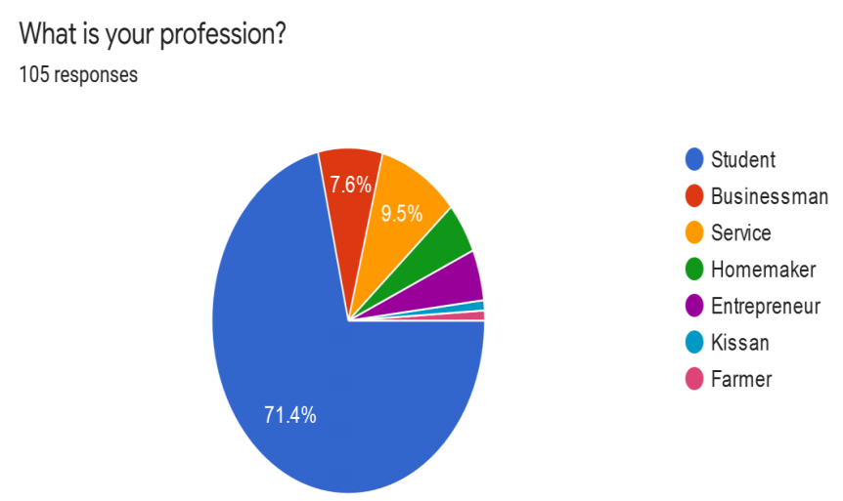

While a huge percentage of the audience of the survey were students, we were also able to get responses of few Farmers, Homemakers, people working in jobs and independent Businessman and Entrepreneur.

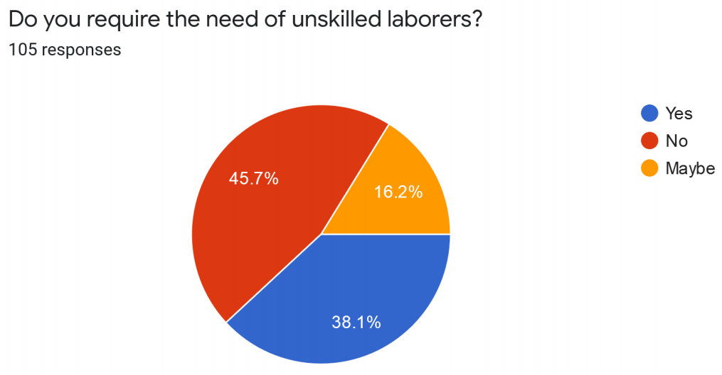

According to the survey we came across a disturbing trend where nearly half of our target audience indicated that they did not require the need of unskilled labourers. On a further deep analysis of the individual answers, we found that it was only the student community that had a very mixed opinion regarding the need of unskilled laborer. We found that all the people of the other professions did require unskilled laborer. We were able to get in touch with a few of them through phone and found out that there is always a need of an unskilled employee. Farmers in particular told how much they have problem in finding labourer during the cutting period of crops.

• This result and analysis helped us to conclude that there indeed is a demand for the project.

Few trends we noticed regarding the past experiences of the people with the unskilled employees.

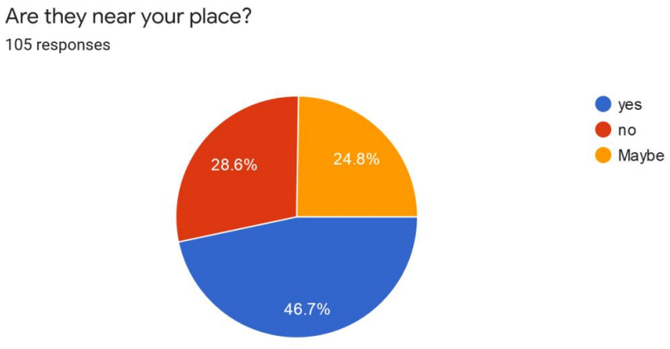

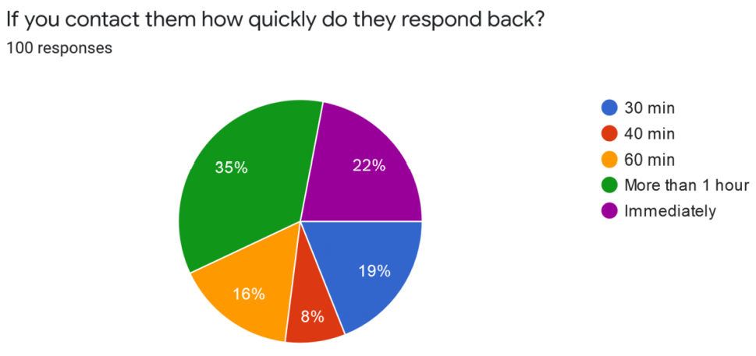

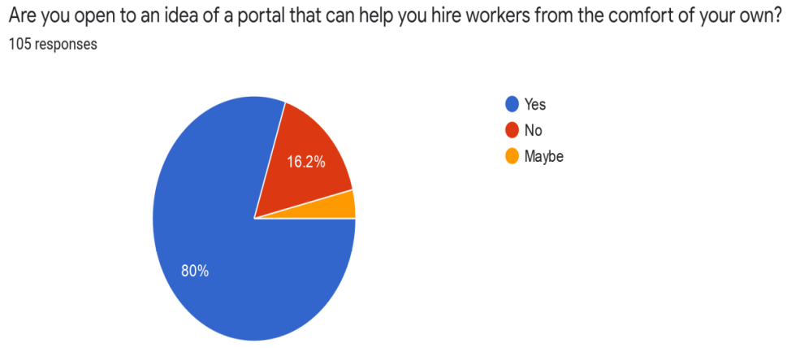

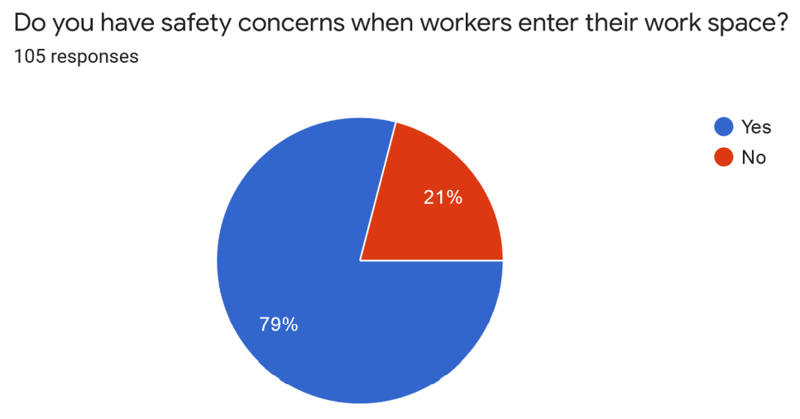

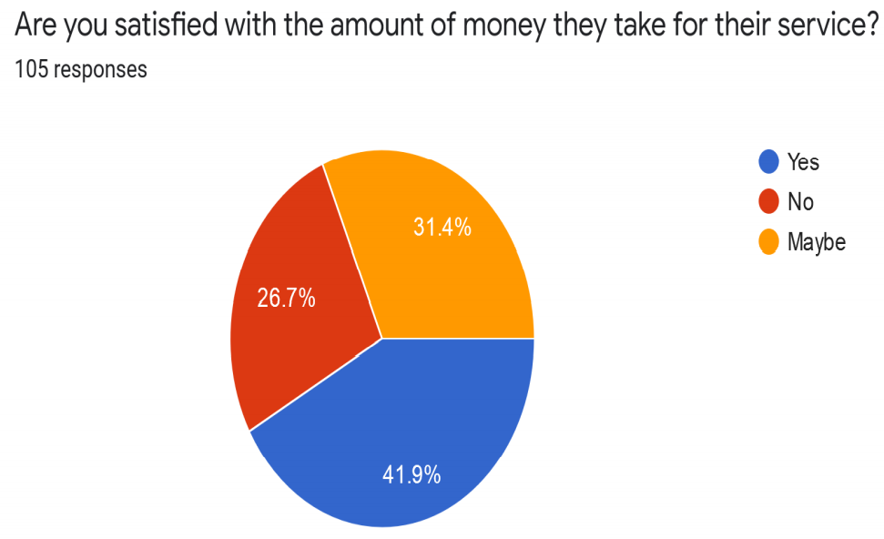

**Figure 1: Market survey using google forms.**

Apart from the google forms we used the platforms like WhatsApp, Facebook and Instagram to upload stories and get responses about the same from another set of users and audiences including our parents, friends and relatives. Following is the analysis and screenshots of the same.

**WhatsApp and Facebook survey/ interaction also done 50+ responses:**

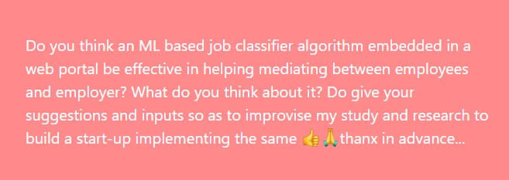

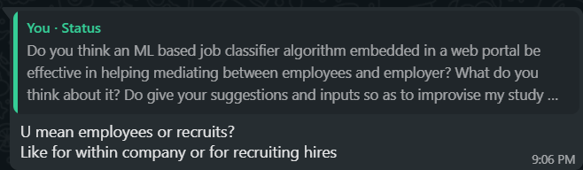

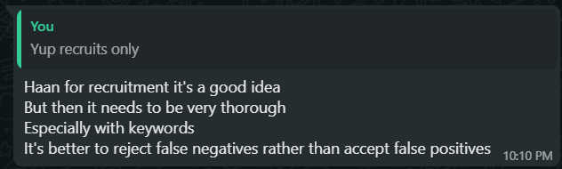

**Figure 2: Survey on fakebook and WhatsApp.**

1. INTERVIEWS WITH EXPERTS AND FAMILY

***Family and friends’ suggestions***

* Question 1: What do you think about the idea of the product?
* Suggestions by family members:
* Person one: I don't completely understand what you're trying to say. From what is written, it only gives the impression that this model is useful for classifying jobs, say data scientist, data engineer, business analyst etc.
* Friend: As far as employer is concerned, what parameter would differentiate him from others? I'm just a beginner in ML, so I don't have much idea.
* I from my one friend told: basically, i want a system/ website that shows the recruits and recommends them jobs as per their resume. and the employer should be shown only those recruit profiles whom they are searching for as per their requirements that they would enter beforehand in an application form.
* I: moreover, this platform will not only be for skilled recruits but also for the unskilled laborers!
* Friend: So basically, when a person inputs their resume, you will categorize them as per the suitable job and store that person's id. The recruiter only has to filter as per job requirement. It's a great idea. But what if a person is equally skilled in networks as well as AI. Will he be included in both categories or there will be a bias?
* I: He will be included in both to be honest so no bias.
* Friend 2: U mean employees or recruits? Like for within company or for recruiting hires?
* I told: Yup recruits only.
* Friend 2: Haan for recruitment it's a good idea But then it needs to be very thorough Especially with keywords It's better to reject false negatives rather than accept false positives.

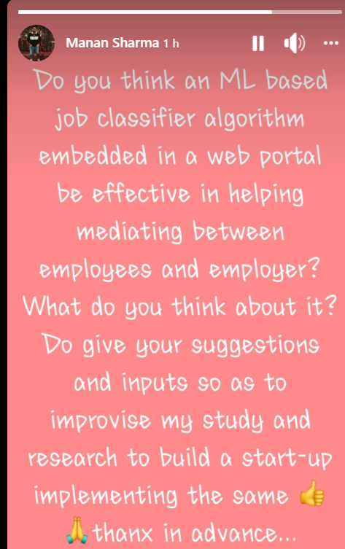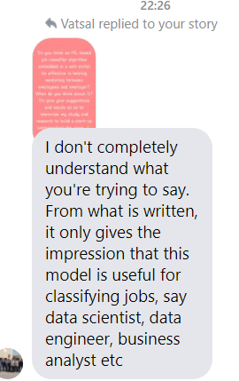

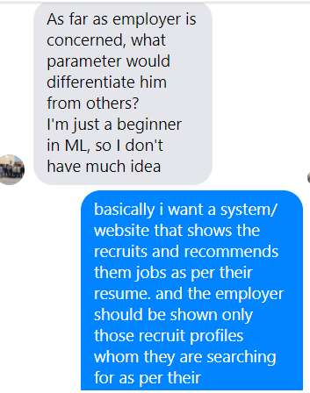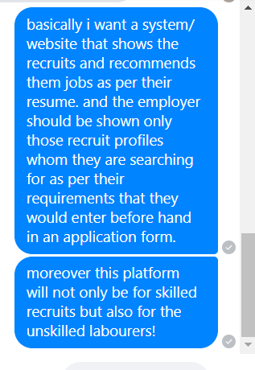

Figure 3: Facebook story upload responses about the marketing of our team Startup.

We had a discussion about the project with my parents. They thought it was a good idea, as there is definitely a dearth of applications to hire unskilled workers. My parents, also told me about the problems they faced while hiring a domestic help a few years back. The process of acquiring their services was cumbersome due to the agencies involved. They said that this project will be able to effectively cut out the middle-man, thus ensuring a fast and efficient method to hire workers. One problem, they pointed out, that our project should handle, should be verifying the authenticity of the workers on our platform. This is essential in order to gain the users trust, which will automatically increase the popularity of our application.

* We gathered their opinions and criticisms as well we talked about the criticisms with our parents and found solutions to them in our recent meeting.
* We planned a special feature (immersive readers) in the GUI of our web portal and a security feature for web application security.

**Competitors**

1. Justdial is an Indian based company that provides search services and is made available on Website and Mobile. It also provides the user with the details of all the service providers. The customers are required to call a hotline number and ask the operator what service they are looking for (e.g., restaurants, hospitals, banks etc.) and in which area. In turn the operator will send them an email and an SMS with the information. Apart from this, customers can search for the information of any specific business on the Website and Mobile Application.

2. INDIAMART InterMESH Ltd. is an Indian e-commerce company that provides B2C, B2B and customer to customer sales services via its web portal. The group began in 1996 when Dinesh Agarwal and Brijesh Agrawal founded the website IndiaMART.com, a business-to business portal to connect Indian manufacturers with buyers. The company is headquartered in Noida, Uttar Pradesh, India. Over the last 10 years, IndiaMART has become the largest e-commerce platform for businesses with about 60% market share.

3. Sulekha: Sulekha is a digital platform for local service businesses in India, matching 20+ million consumers with 50,000 service professionals across 200 categories in about 40 cities. Sulekha focuses on expert services clustered around Home, Life and Self and where the user need is customized. Using technology and domain intelligence, the platform seeks to understand the user need in detail and matches it to verified service professionals who are profiled. The service is free to use for consumers and service professionals pay the platform for performance in the form of verified, matched service requests.

1. DESIGN APPROACH AND DETAILS
   1. DESIGN APPROACH AND BUSINESS PLAN

We will have a basic layered architecture of our system application that is an ML classifier algo embedded web portal named after our team Mendit. On the basis of the core nature and viewability of the component to the users/ customers the architecture will be built as shown in the following figure.

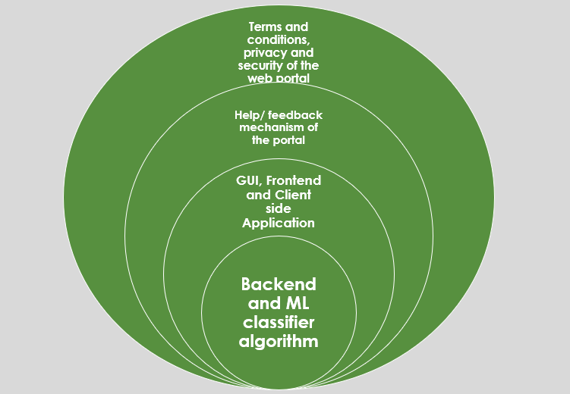

**Figure 4: layered architecture of our system.**

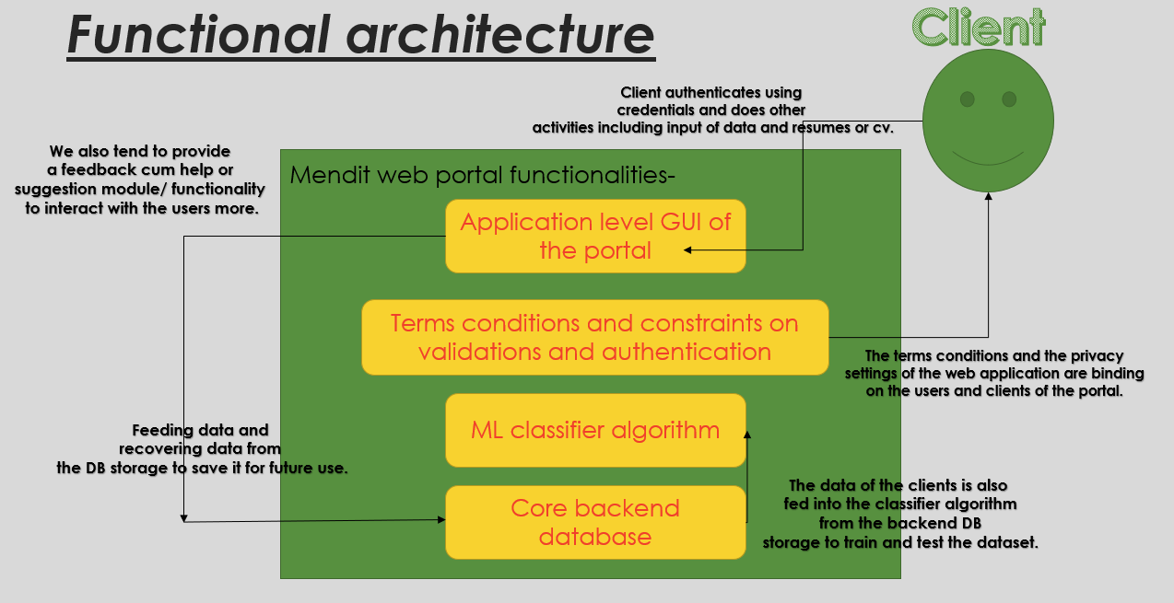

**Figure 5: Functional architecture of our web portal.**

BUSINESS PLAN MODEL

* **Value proposition:** We will have some features for the visually impaired in our portal for instance transcript readers and immersive readers.
* **Target market:** The target stakeholders will be the unskilled and skilled workers as well as vendors and employers who will hire them
* **Competitive advantage:** The competitive advantage is the use of ML based recommendation system with the USP of website to be friendly for the visually impaired.
* **Cost structure:** A list of the fixed and variable expenses your business requires to function, and how they affect pricing.
* **Key metrics:** profit margins and the economic growths per year and also the number of customers served and satisfied per unit time.
* **Resources:** The physical, financial, and intellectual assets of your company including the website and algorithms used and the human resources used.
* **Problem and solution:** The problem is that people especially housewives not able to find house help or vendors not able to outsource unskilled and skilled labor easily we will mediate between them efficiently.
* **Revenue model:** Given as a balance sheet later with cost and expenditure.
* **Revenue streams:** Through advertisements on our portal from commercial partners and as well as from the employers and vendors using our portal regularly using a subscription.
* **Profit margin:** The amount your revenue exceeds your business costs.

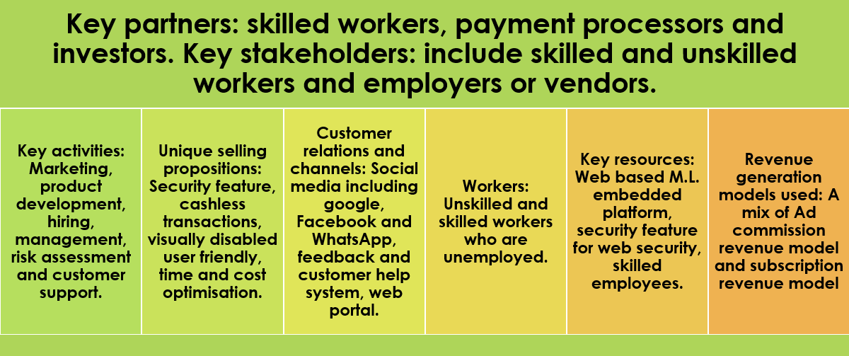

**Table 1: Business model for our proposal.**

* 1. REQUIREMENT ANALYSIS

**Functional Requirements**

In this section we will briefly discuss different functional requirement of

different users.

**Admin**

1. Manage Job Seeker and Employer Profiles

2. Manage Payments of Both Employer and Job Seekers

3. Add New Services, Related to Employers or Job Seekers

4. Send Message to Employer and Job seeker for Subscription etc

5. Provide Roles and Authentication to Users

6. Ability to change the look and feel of your site by changing template

7. Most Recent Jobs to be displayed on home page

8. Search jobs based on keywords, categories, locations etc

9. Create / Edit / Save as many icons sets as you like

10.Location management console to add/edit/remove locations for which

jobs can be posted

11.Manage premium employers

12.Admin can Add/Edit/Delete/Approve/Disapprove any job

13.Private labelled and fully integrated with your existing web site’s look and

feel.

14.Search Job seekers and Employers on the basis of Keyword, name, Email address, Country, etc

15.Manage Featured Employers Showcase.

16.Setup multiple admin with file access privileges

**Employer**

1. Ability to Search resume by keywords, job category, days since posted.2. Post jobs with detailed job description (job title, company name, company

URL, location, salary, job type, work type, description, required skills...)

3. Ability to create and edit a company profile.

4. Ability to add a Company Logo.

5. Retrieve passwords reset by automated email.

6. Employer Registration

7. Reporting information on how much time left on each job posting and

how long left on CV access

8. Payment option by invoice, credit/debit card.

9. Information on number of vacancy viewings and applications

10.Register and sign-up online for Memberships, Job packages, job postings

or resume database access.

11.Option of including company profile and logo.

12.New Account Notification - an email message is sent to them as auto

responder with username and password.

13.Retrieve passwords by automated email.

14.Update profile at any time.

15.View Submitted Job Seeker CV

16.Download CV or application submitted by jobseekers

**NON-FUNCTIONAL REQUIREMENTS**

**Job Seekers**

1. Apply for a job with the click of a button

2. Resume Posting.

3. Automatically retrieve passwords by email.

4. Job Seeker Registration

5. Login and update profile, including forgotten password reminders

6. View Application History from profile

7. Powerful online job search tool.

8. Job seeker sets ’privacy level’ to control how much information is visible

to employers through resume searches.

9. Search jobs by location, qualification, categories, company, location,

experience and keywords.

10.Hide contact information.

11.Add multiple lists of qualification and experience.

12.Ability to add and submit Photos to profile.

13.Ability to add Cover Letter when apply for job.

14.Add, Edit, Activate or Delete Job Search Agent.

**Non-Functional Requirements**

1. Secure access of confidential data (user’s details). SSL can be used.

2. 24 X 7 availability

3. Better component design to get better performance at peak time

4. Flexible service-based architecture will be highly desirable for future

Extension.

**Hardware Requirements**

• Processor: Intel Pentium And Above Version

• Speed: 1.60 GHz

• Hard Disk: 20GB And Above

• Key Board: Standard

**Software Requirements**

• Operating System: Windows 7

• Data Base: MySQL

• Tools: JOOMLA, AJAX, PHP, JQUERY

REPRESENTING THE REQUIREMENTS AND ELICITATION

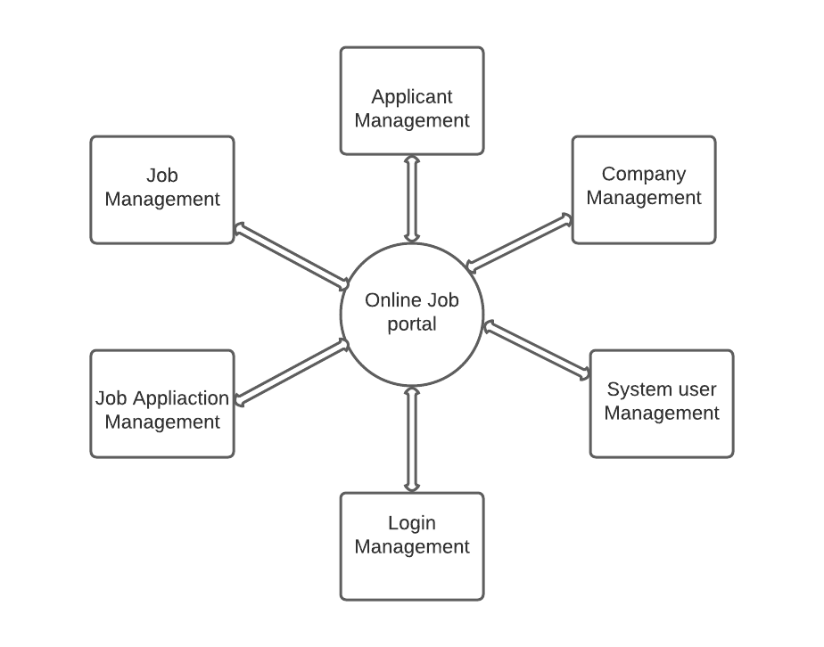

**Figure 6: High level schema for our system**

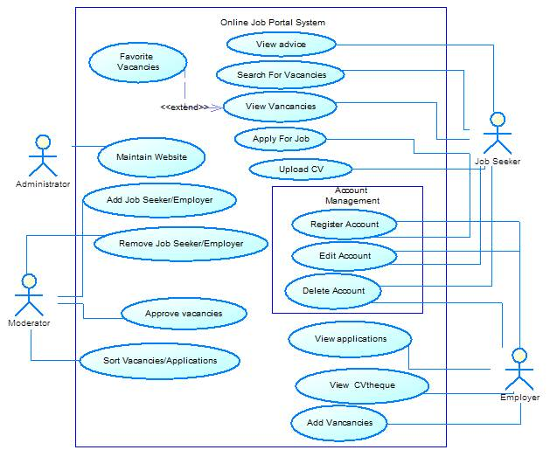

**Figure 7: UML use case model for the requirements of our system.**

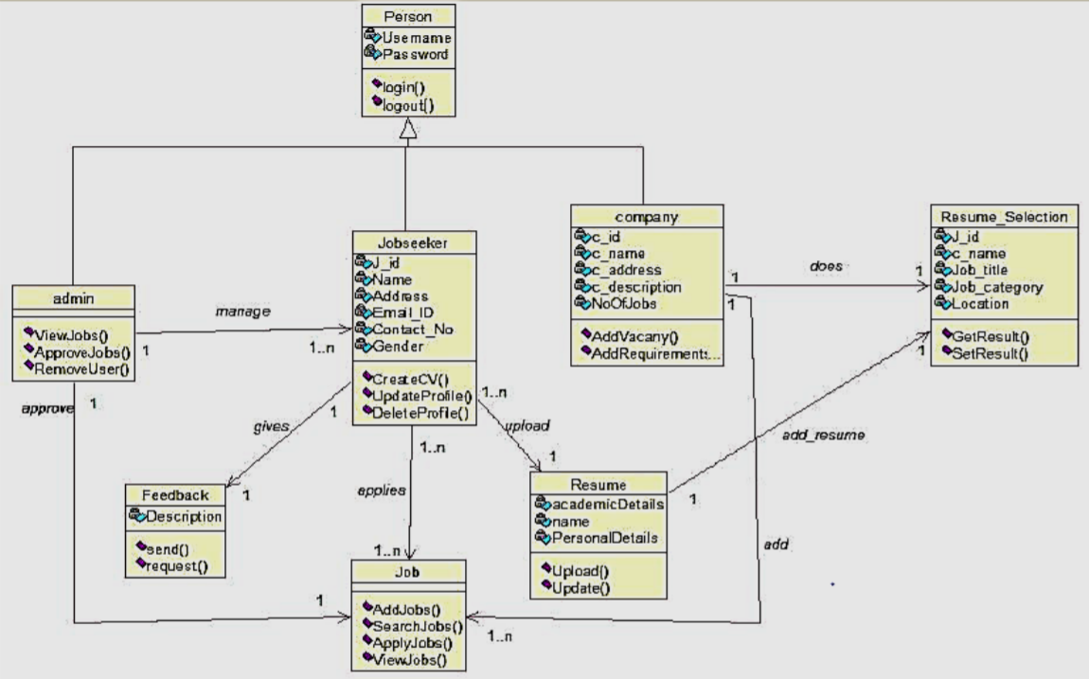

**Figure 8: Low level detailed database schema for the project.**

Following are our constructed databases using Apache server of Xampp and MySQL technologies for our web portal.

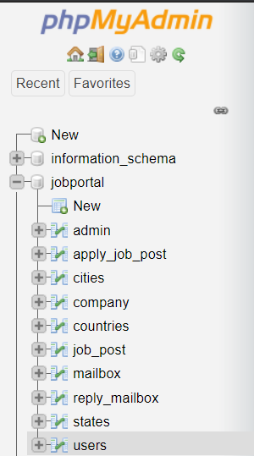

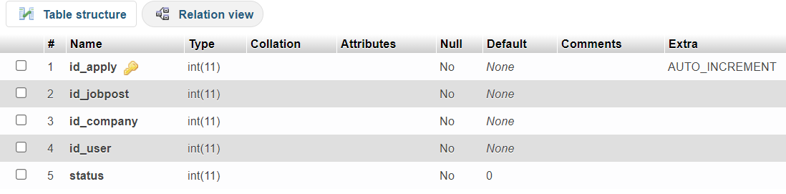

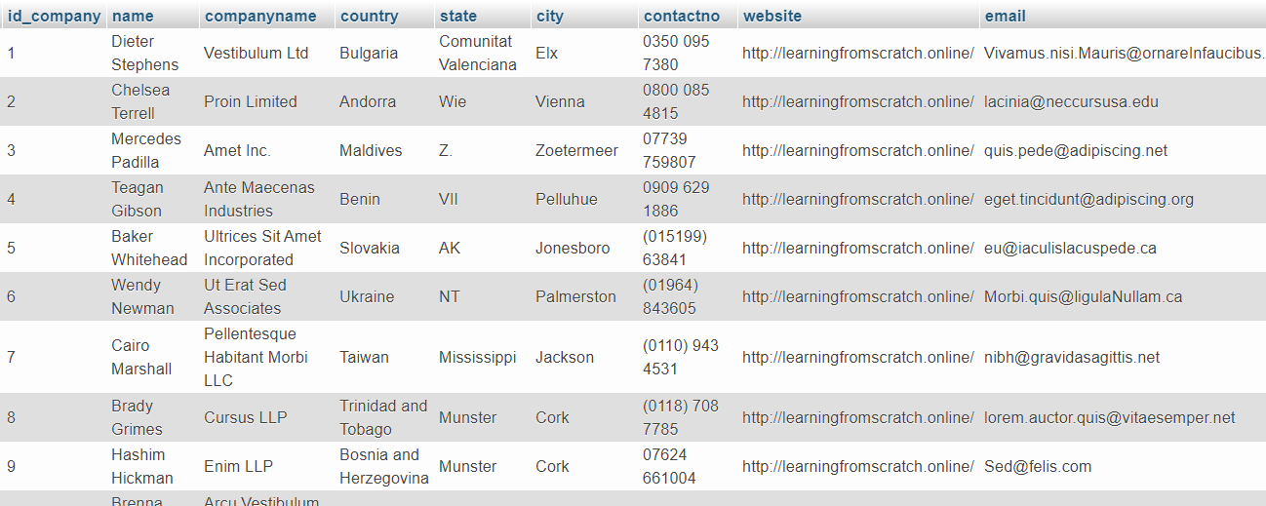

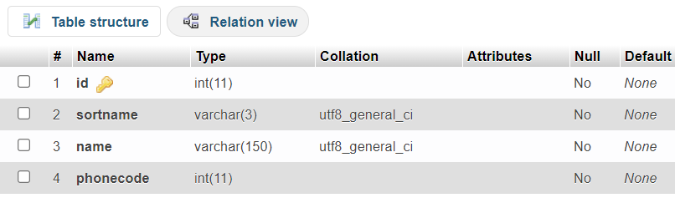

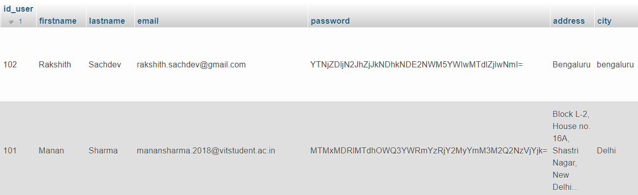

* 1. LOGO DESIGNING AND SURVEY RESULTS

***Logo designed***

There were two logos designed by two different members of our team following the guidelines and the HCI rules that we wanted to follow while designing of the same for our Startup company and the two logos designed are as follows. Then we conducted a survey to reach to the conclusion of our logo and the results and the interpretations of the same are listed in the following sub section.



Figure 9: The first logo designed by our team.



Figure 10: the second logo designed for our web portal by our team.

Then we conducted a survey and polls on different social media platforms including google forms, WhatsApp and Facebook to gain inputs and select among the two of the logos that our team designed and finalized. The results and their responses are as follows.

WhatsApp updates and stories responses and screenshots:

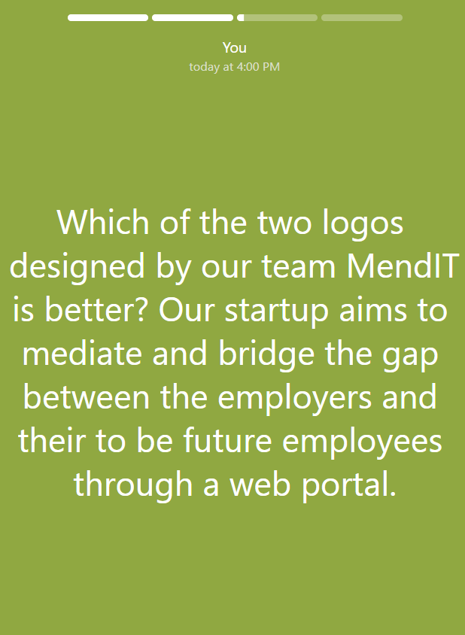



Figure 11: the WhatsApp story and status updates and the following are the responses.

***Responses:***

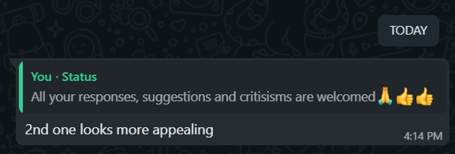



Facebook stories posted and response updates:

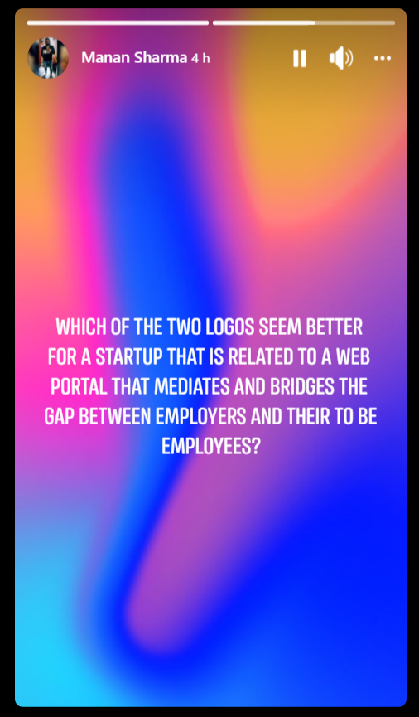

Figure 12: the story update on my Facebook platform about our team MendIT’s logo.

We even conducted an online google forms survey to decide about which logo to keep for our Startup website and the following responses along with responses from Facebook and WhatsApp lead us to take the decision about the logo.

URL of the Google survey form created by our team is as follows: <https://forms.gle/3xXSX6RSNthAKuX66>.

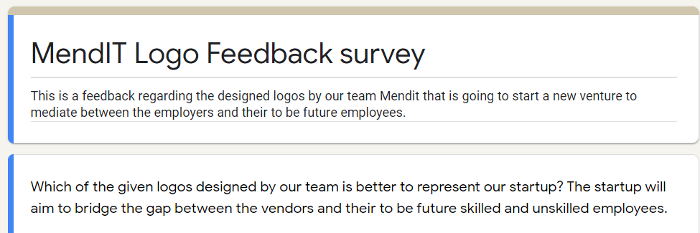

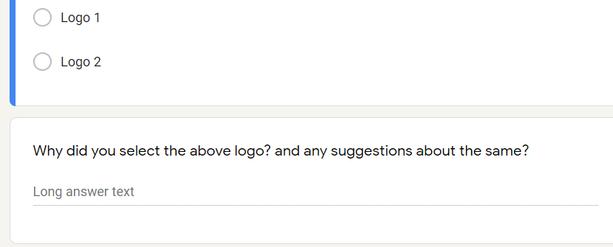

Figure 13: the questions and the options of the google form survey.

Responses and its results are as follows:

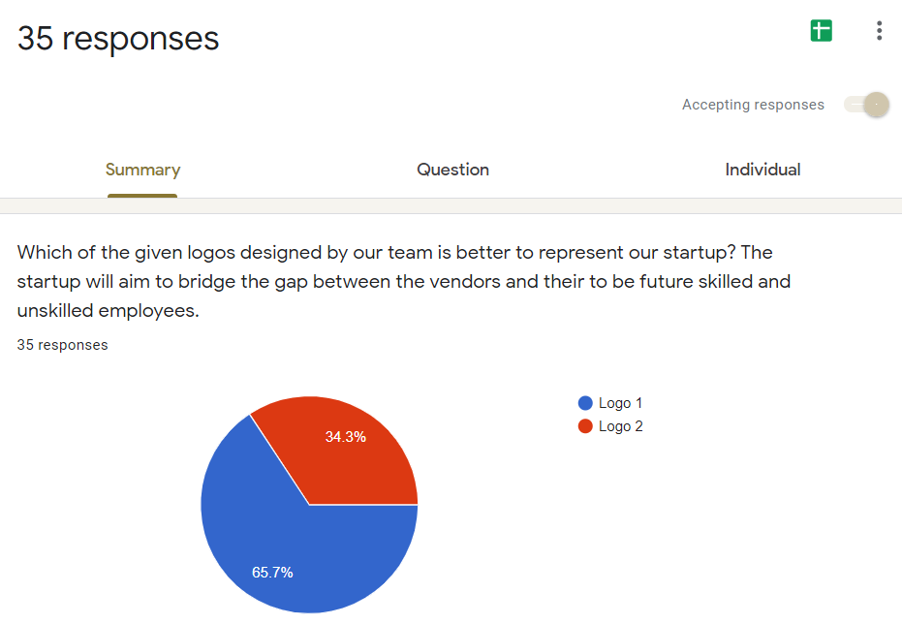

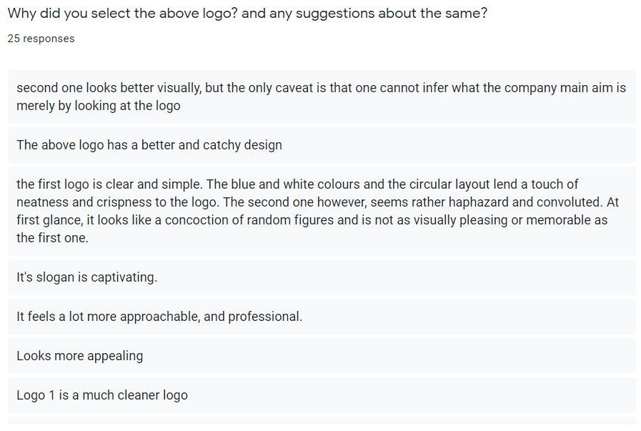

Figure 14: the chart and the analysis of the responses from the google forms.

And hence it’s pretty much evident from the responses of our fellows, parents, relatives and teachers that the first logo is more appealing, professional, cleaner and better in context than the second one and hence going in line with the responses and the mindset of our respondents and volunteers we choose the following logo for our Startup web portal MendIT.



Figure 15: Chosen logo by our team.

* 1. USABILITY TESTING OF GUI AND REPORT

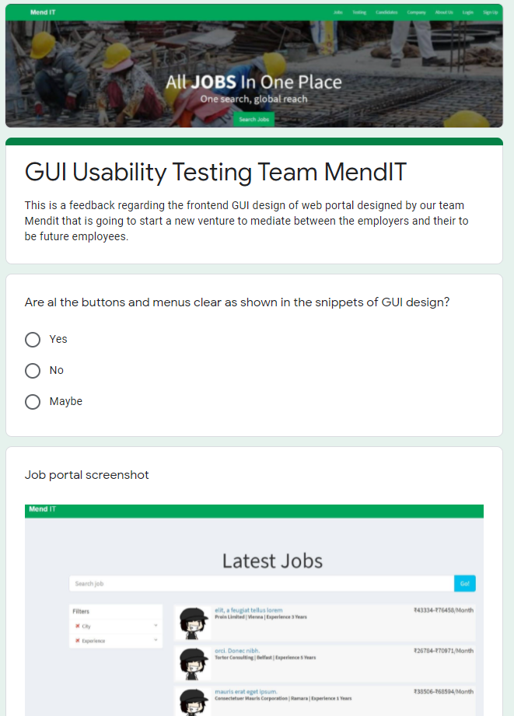

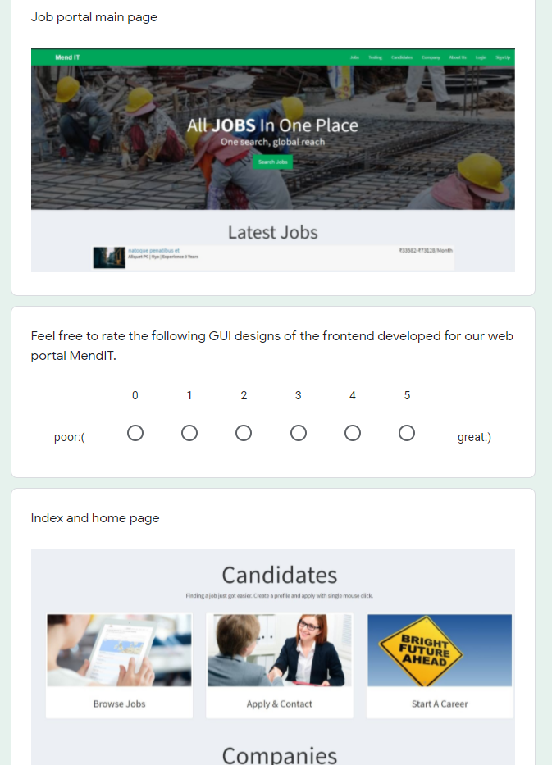

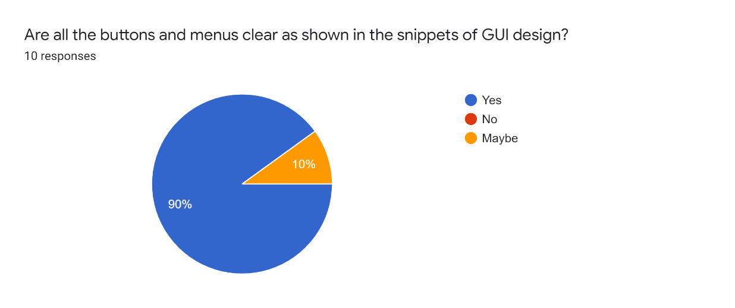

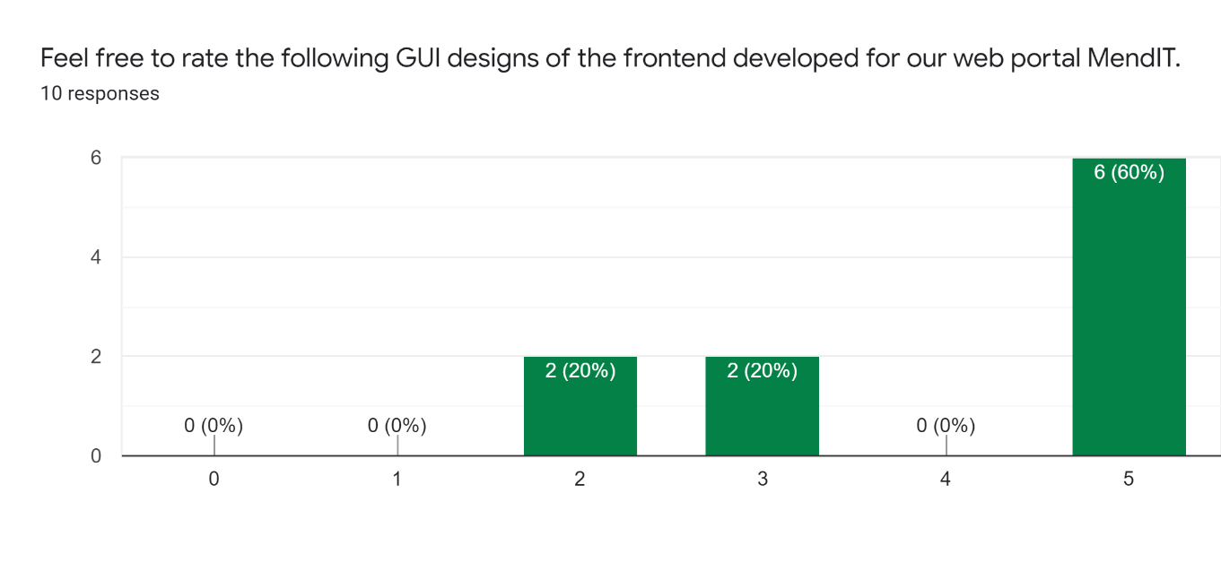

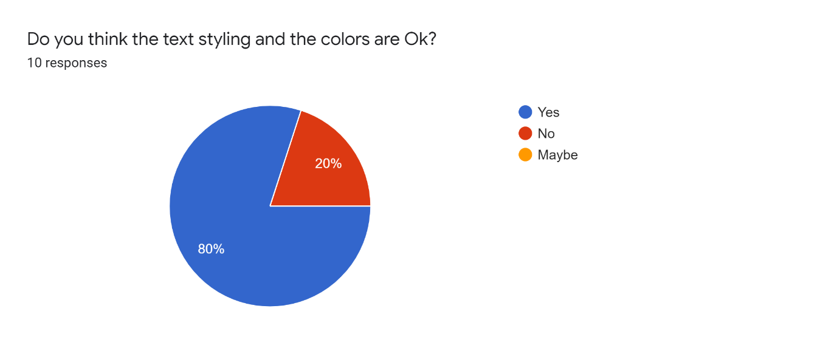

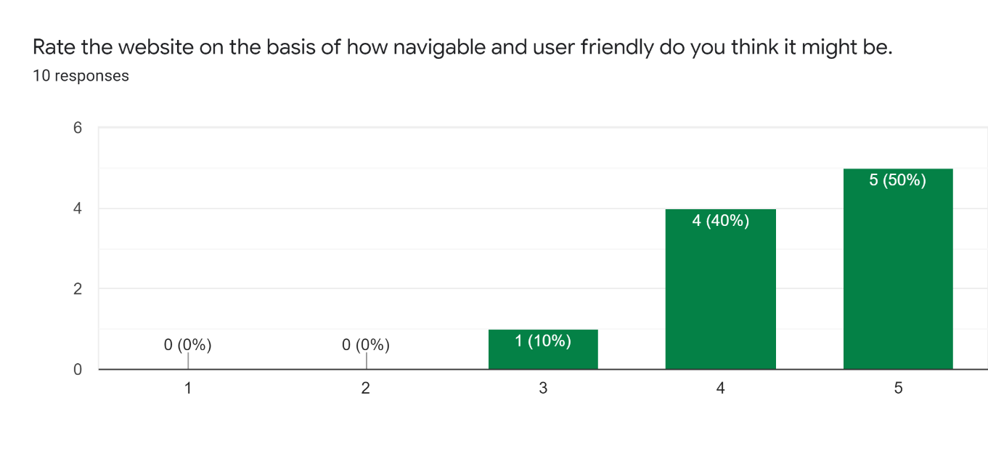

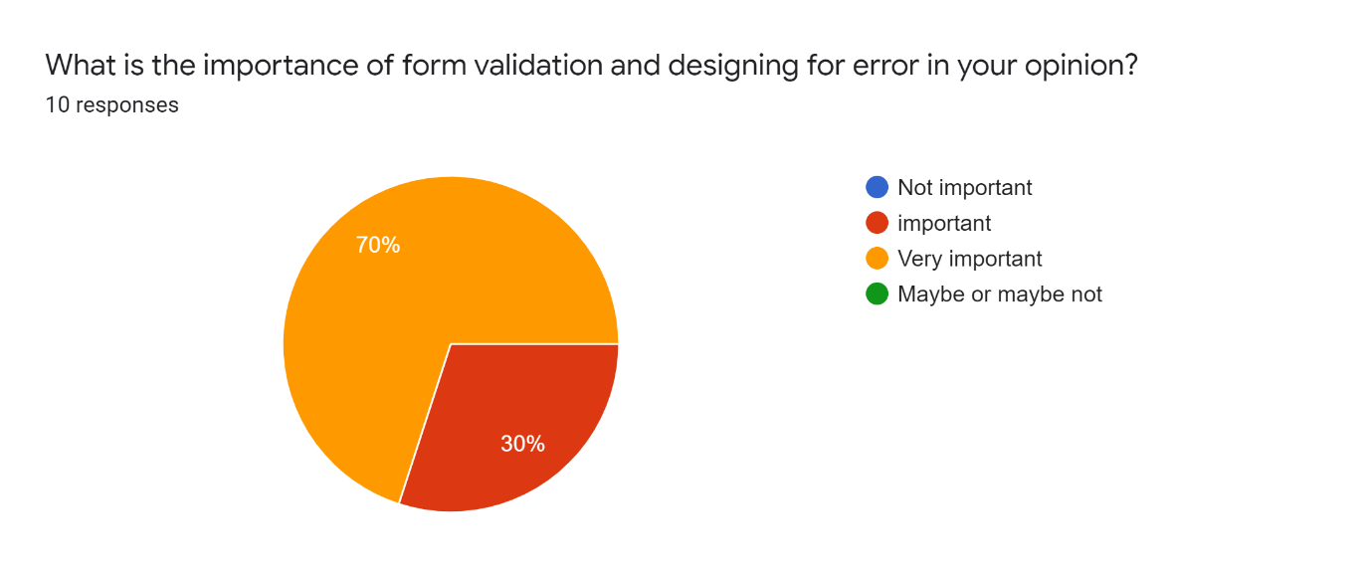

**Figure 16: Usability test form of GUI and responses.**

Testing report of modules

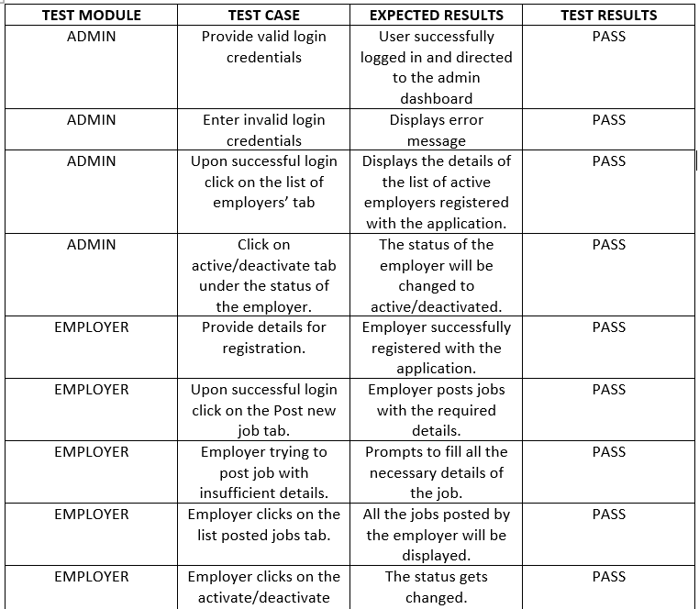

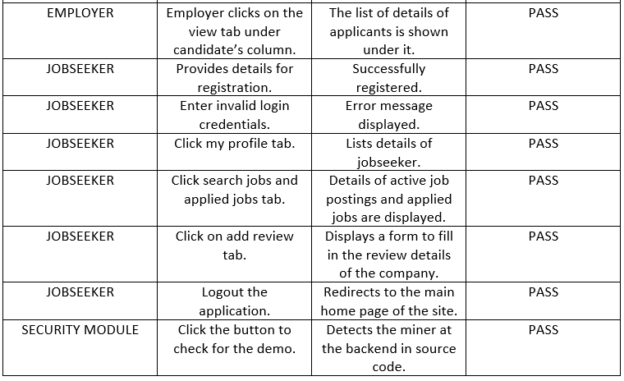

**Table 2: Testing report of modules.**

1. **NESSACARY PERMISSIONS AND LEGAL ASPECTS**

• For starting a start up in India, we first need to record it in Indian official records i.e., Ministry of Corporate Affairs (MCA). This can be done by visiting one of the corporate office or can also be done by filling one of the eForm.

• Step1: Acquire Digital Signature Certificate (DSC):

• The Information Technology Act, 2000 has provisions for use of digital signatures on the documents submitted in electronic form in order to ensure the security and authenticity of the documents filed electronically.

• Step 2: Acquire Director Identification Number (DIN)

• The concept of a Director Identification Number (DIN) has been introduced for the first time with the insertion of sections 266A to 266G of Companies (Amendment) Act, 2006.

• Step 3: Create an account on MCA portal- New user registration

• Step 4: Incorporate or Apply for the company to be registered.

• Indian company law regulates the corporations formed under the Section 2(20) Indian Companies Act 2013.

"Company means a company incorporated under this Act or under any previous Company Law". The Companies Act 2013 is an Act of the Parliament of India on Indian company law which regulates incorporation of a company, responsibilities of a company, directors, dissolution of a company.

• All the dealings of the website would be Strictly adhered by the Information technology Act, 2000. It is the primary law which deals with cybercrime and electronic commerce. Hence the users of the website give the permission to the employees of the website to use the data for police verification etc.

• The employers must strictly adhere to the Indian Labour laws, meaning they will provide them with minimum wages, and other features promised by the act.

Any modification, termination of contract must adhere to the Indian Contract Law and the changes must be in respect to the labors law and should not violate workers right in any way possible.

**General Terms and Condition**

1. MendIT (and related products) or service or product that is subscribe to or used (whether the same is paid for by you or not) is meant for the Purpose and only the exclusive use of the subscriber/registered user. Copying or downloading or recreating or sharing passwords or sublicensing or sharing in any manner which is not in accordance with these terms, is a misuse of the platform or service or product and IEIL reserves its rights to act in such manner as to protect its loss of revenue or reputation or claim damages including stopping your service or access and reporting to relevant authorities.

2. The site is a public site with free access and Info Edge assumes no liability for the quality and genuineness of responses. While MendIT will also have a dedicated team in the company that will check all the application with the authorities, the individual/company can conduct its own background checks of all responses.

3. You give us permission to use the information about actions that you have taken on Naukri.com in connection with ads, offers and other content (whether sponsored or not) that we display across our services, without any compensation to you. We use data and information about you to make relevant suggestions and recommendation to you and others.

4. The platform may contain links to third party websites, these links are provided solely as convenience to You and the presence of these links should not under any circumstances be considered as an endorsement of the contents of the same, if You chose to access these websites you do so at your own risk.

5. Whilst using this platform an obligation is cast upon you to only provide true and correct information and in the case of creating a profile you undertake to at all times keep the information up to date.

6. MendIT will not be liable on account of any inaccuracy of information on this web site. It is the responsibility of the visitor to further research the information on the site. Any breach of privacy or of the information provided by the consumer to MendIT to be placed on the website by technical or any other means is not the responsibility of MendIT.

**Employers Terms and Conditions**

1. You will comply with all applicable data protection laws in relation to the processing of personal data; and not process personal data in an unlawful manner and excessive with regard to agreed purposes as defined in the privacy policy and this terms and conditions.2. By posting/uploading a job posting on the website you confirm that you have obtained all licenses/permits as are necessary for recruitment.

3. MendIT offers no guarantee nor warranties that there would be a satisfactory response or any at all response once the job is put on display.

4. MendIT reserves its right to reject any insertion or information/data provided by the subscriber without assigning any reason either before uploading or after uploading the vacancy details, but in such an eventuality, any amount so paid for, may be refunded to the subscriber

5. You agree to follow all the labour laws required to hire any employee and

agree to minimum wage act.

**Job Seekers terms and condition**

1. MendIT offers no guarantee nor warranties that there would be a satisfactory response or any response at all once the resume/ insertion or information/data is fed by the user

2. MendIT reserves its right to reject and delete any resume/ insertion or information/data fed in by the user without assigning any reason.

3. MendIT has the right to make all such modifications/editing of resume in

order to fit resume in its database.

4. You consent to your application, documents and any responses sent to you by the Employer or vice versa through mendit.com being processed and analyzed by mendit.com according to these terms of use and mendit.com's Privacy Policy.

5. offers neither guarantee nor warranties that there would be a satisfactory response or any response at all once the resume is put on display.

6. It shall be the sole prerogative and responsibility of the individual to check the authenticity of all or any response received pursuant to the resume being displayed.

7. The User of these services does not claim any copyright or other Intellectual Property Right over the data uploaded by him/her on the website.

8. In case of a dispute MendIT won’t be held accountable for any inconvenience caused by either the employer and the employee. Discrepancies And how to resolve them:

• Security issues and certification problems:

• In MendIT we will ensure the security is uptight and that all security measures are taken to ensure the confidentiality and the security of the users.

• We will keep website’s safety features up to date. But a lesser known but valuable step is obtaining an SSL certificate. In a nutshell, this is a way of keeping your customers safe during transactions. Not only a sensible move, but one that will give you preferential ranking with the likes of Google!

• Backing up of the website’s data will be done regularly to prevent the hacking of the website and protecting the valuable data of the company.

• Whilst using this platform an obligation is cast upon you to only provide true and correct information and in the case of creating a profile you undertake to at all times keep the information up to date. This helps to easily terminate potential law suites due to frauds and lack of understanding thus keeping the brand image safe.

• In case wrong information is provided by the employer or the employee, it may lead to deactivation of the MendIT accounts and due action would be taken.

**Discrepancy due to hardware issues**

**Mitigation:**

1. A significant portion of a business’ day to day work is done on computers. From editing documents and spreadsheets to creating reports, files are created and modified regularly. Each time another file is saved on your server, storage space decreases. Buying and maintaining new servers to grow the size of your digital storage costs money.

With cloud storage, you eliminate the need for costly internal servers. Running out of digital space no longer results in a panicked order for another server, it is a quick call to your cloud manager to ask for a storage increase.2. By using Cloud storage, we always have data stored and available at hand from anywhere around the globe. This enables easy movement of data and helps in expansion.

**Discrepancy between the Employee and Employer**

At MendIT we value user experience very seriously. Any misbehavior on the part of the employee would be handled by a special team which would take suitable action which could be as severe as a permanent ban on the employee. While at the same time any misbehavior not in accordance to the labor act would let to permanent suspension of the employer’s agency or the employer

from all MendIT related platform.

TERMS AND CONDITIONS PAGE OF WEBSITE

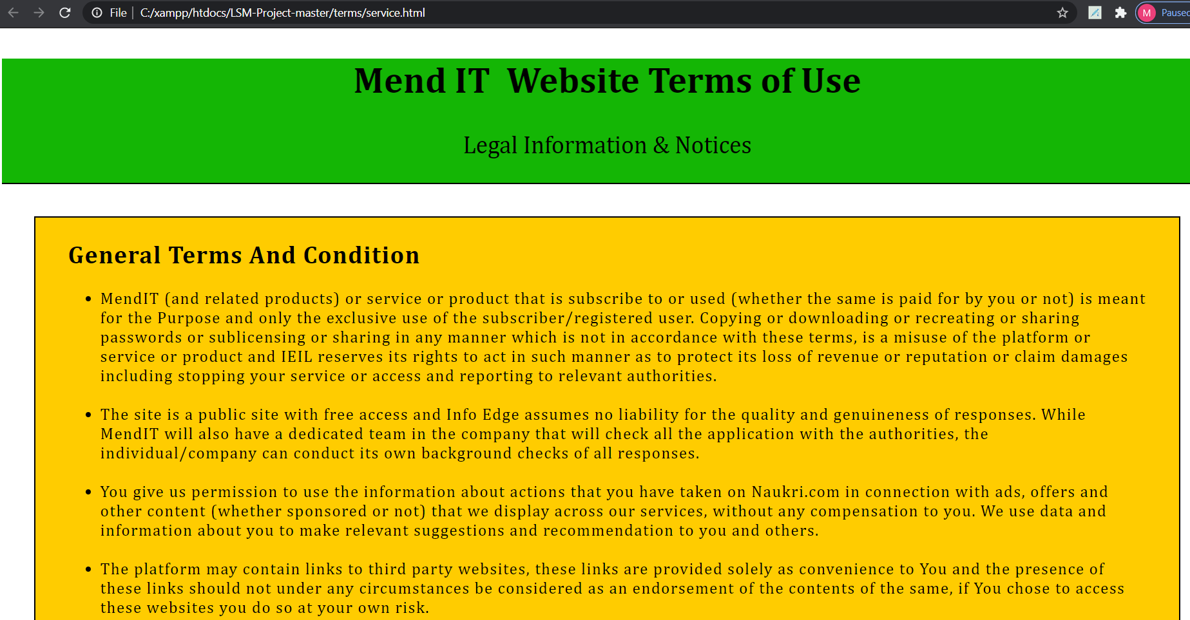

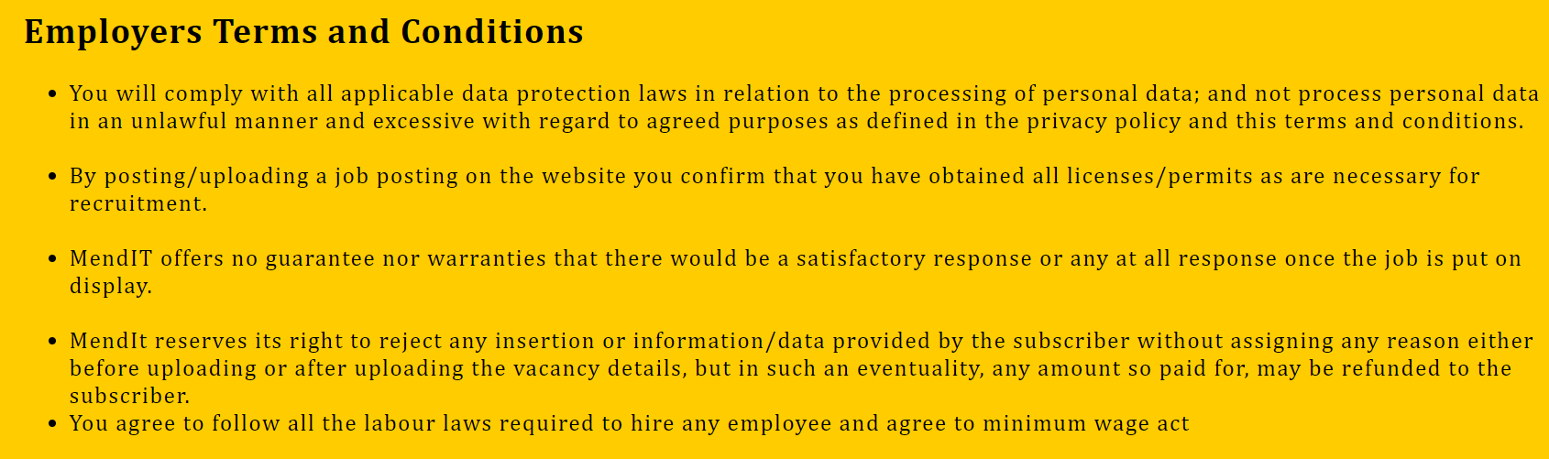

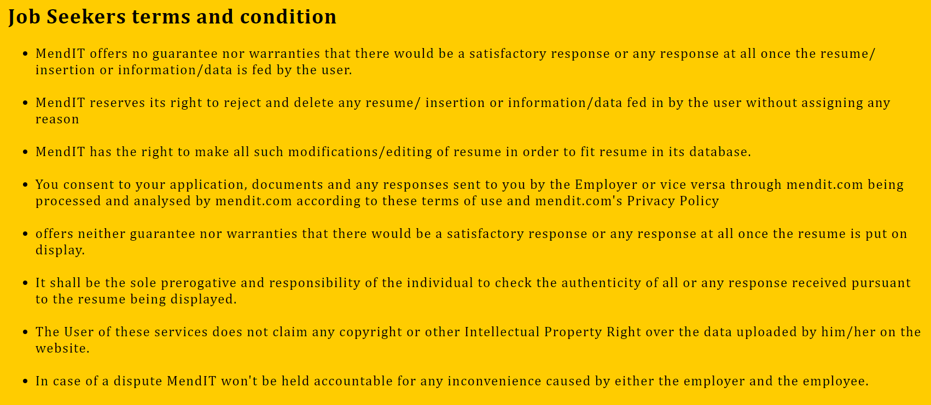

1. PROJECT DEMONSTRATION

Home page

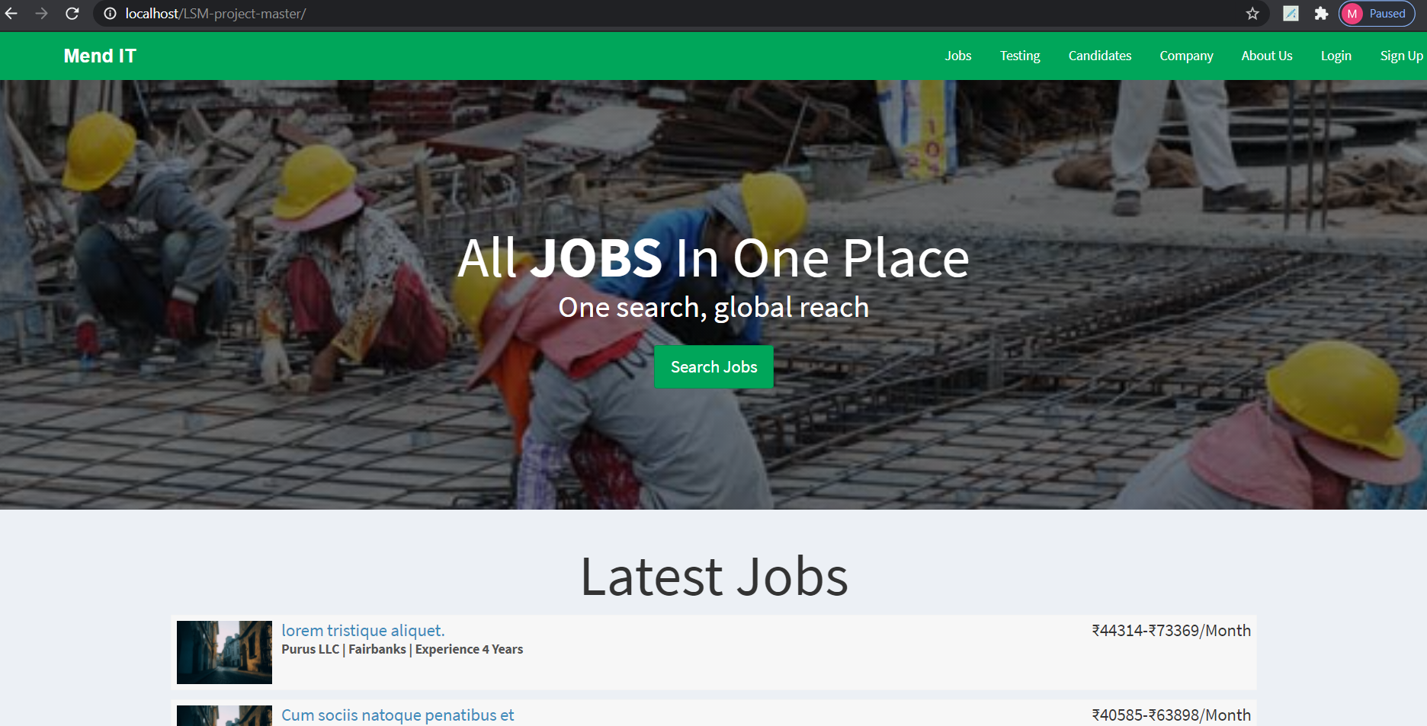

All New Jobs Updates



OVERALL STATISTICS

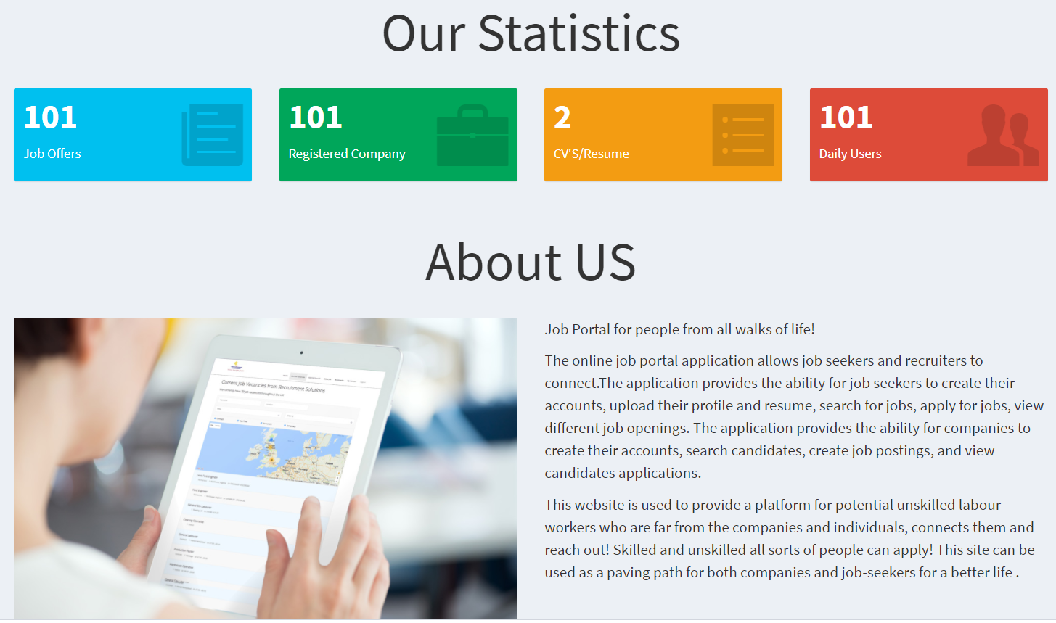

SIGN UP

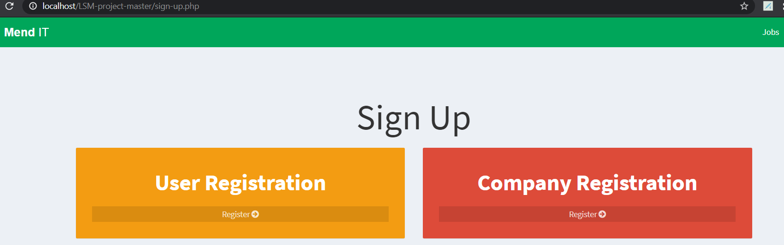

COMPANY SIGNUP

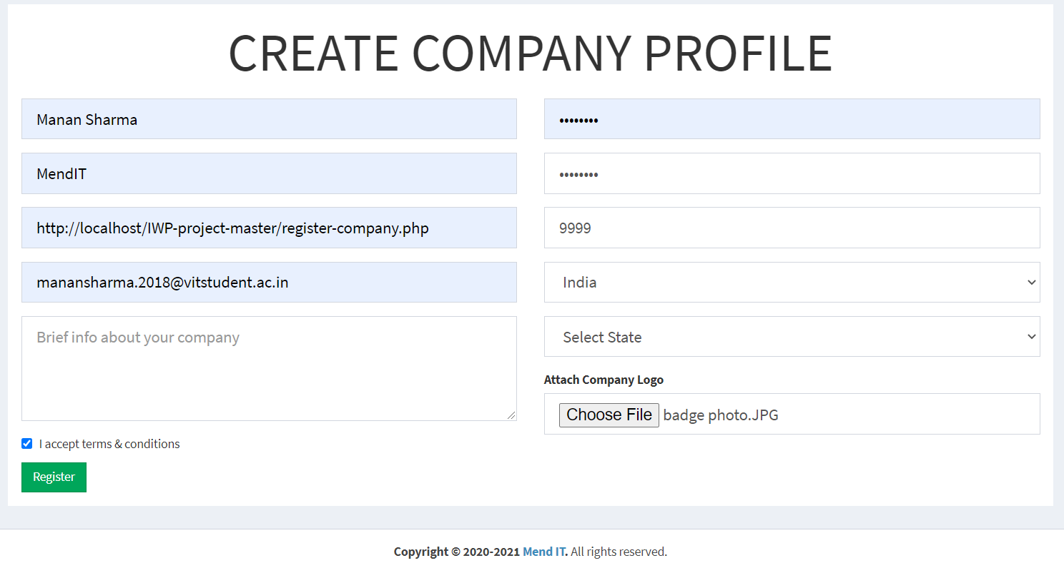

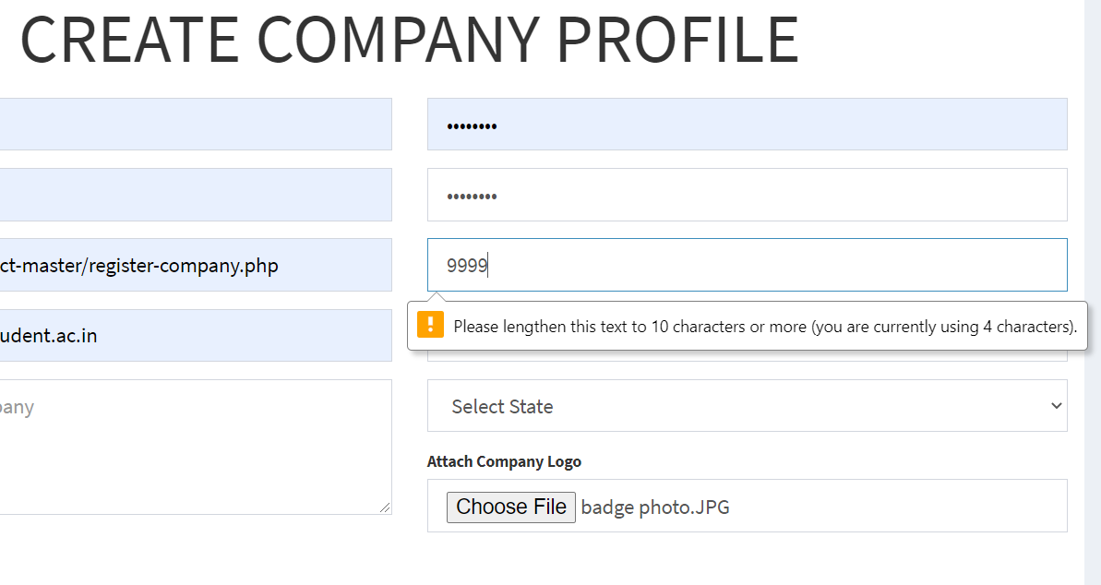

CANDIDATE SIGNUP

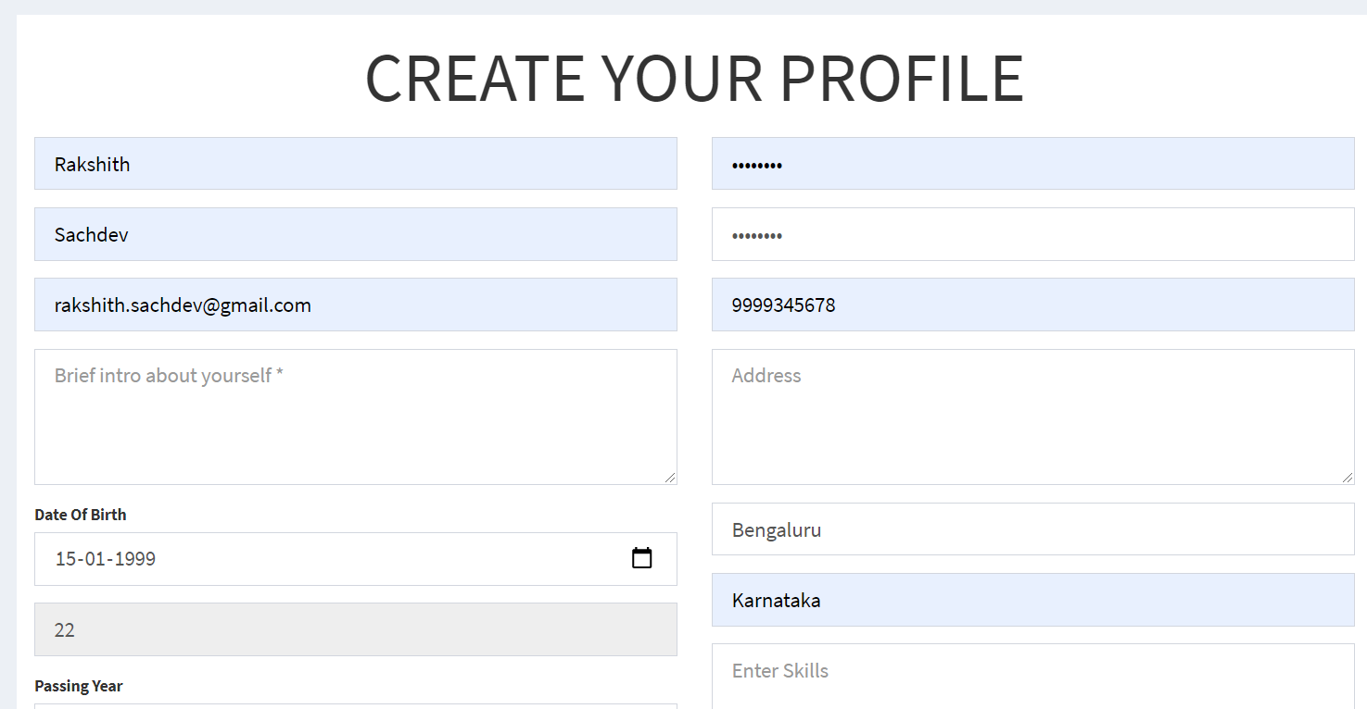

COMPULSORY FILE UPLOAD FOR USER VERIFICATION

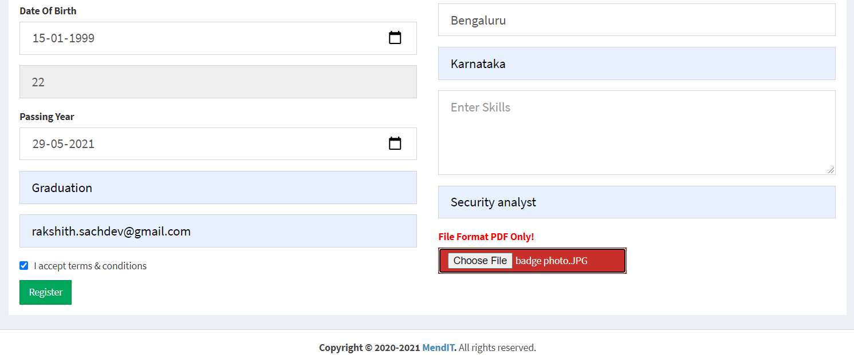

LOGIN PAGE (WITH TERMS OF SERVICE)

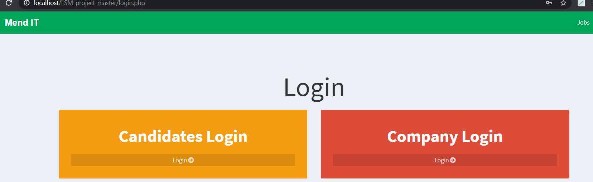

COMPANY LOGIN

1. Company Profile can be updated easily

2. Create New job Posts

3. Edit existing job posts

4. Check for job applications received

5. Mails regarding contact and query

6. Easy facility of Password change

7. View whole database of resume uploaded for current job posts

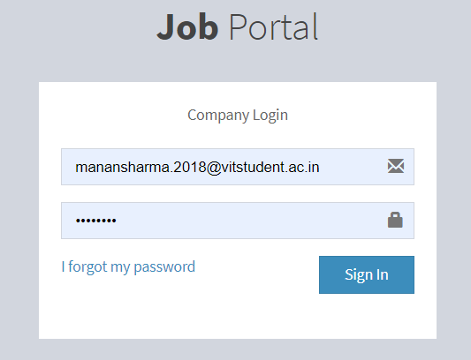

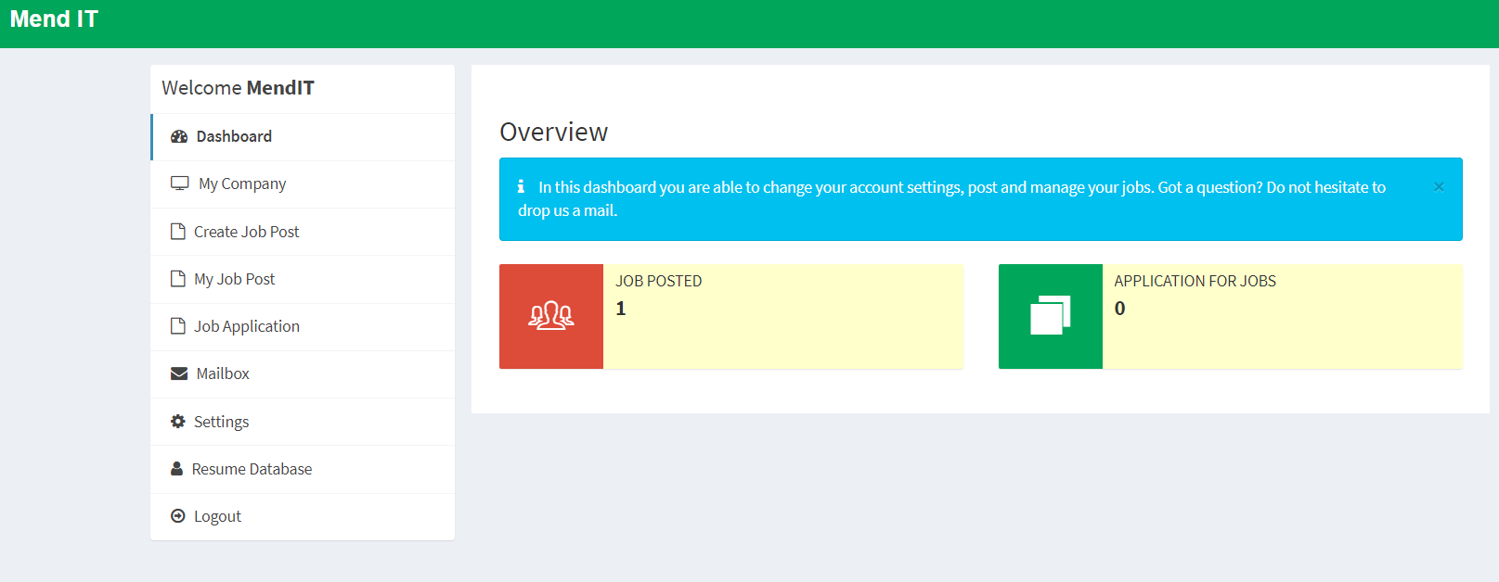

Check applicants profile easily (and ALSO KNOW WHETHER THE PROFILE IS VERIFIED)

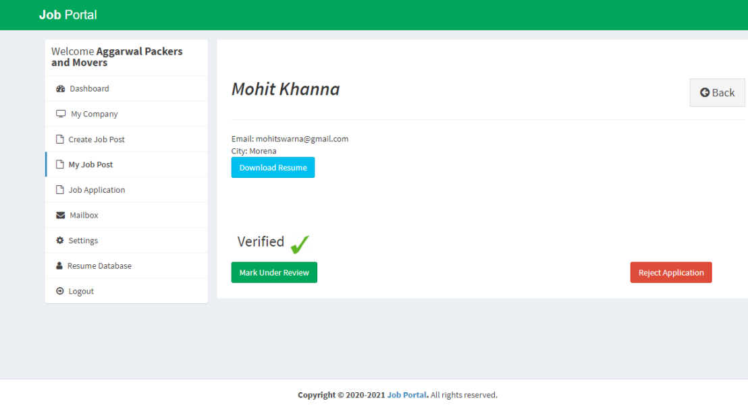

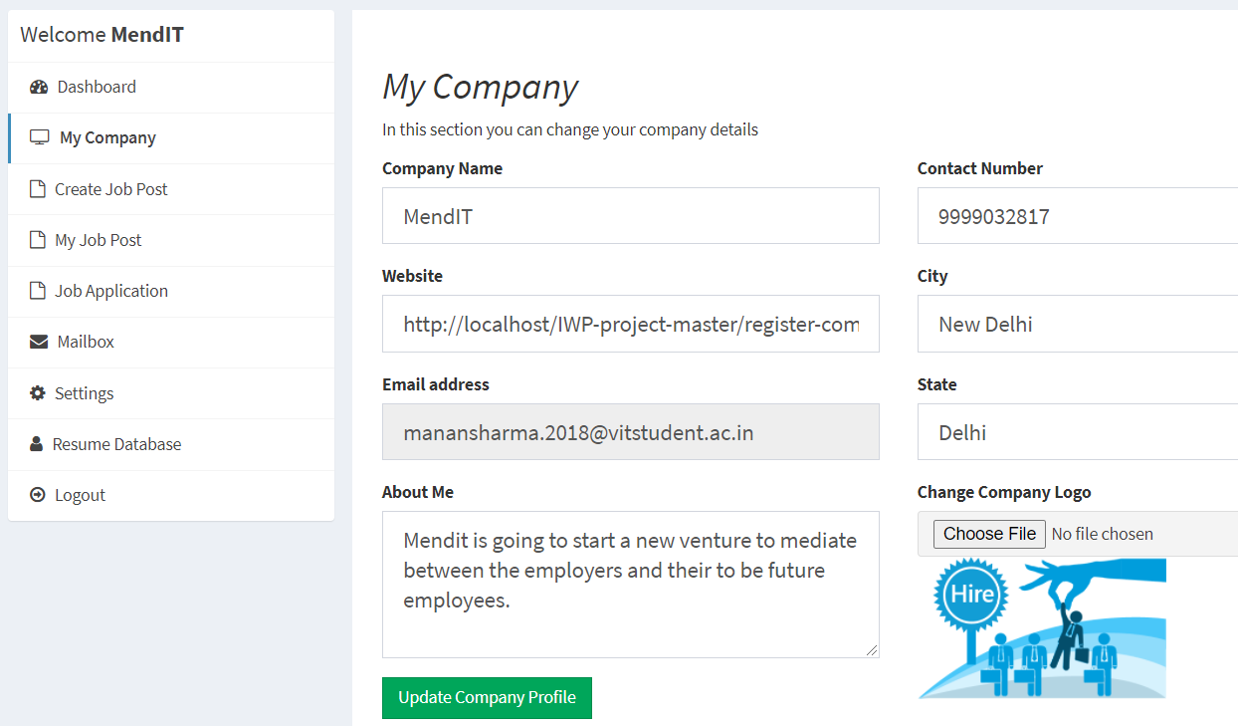

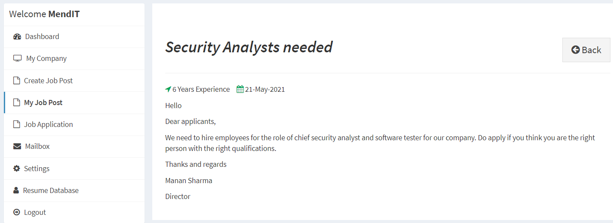

CANDIDATE LOGIN

1. User friendly interface for job application registration

2. Easy updating of candidate info

3. Send and receive mails for queries easily

4. Check for current status of your job application

5. Easily check for jobs using keyword search interface

6. For security purpose, easily update your password

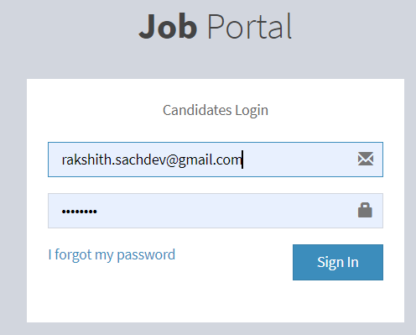

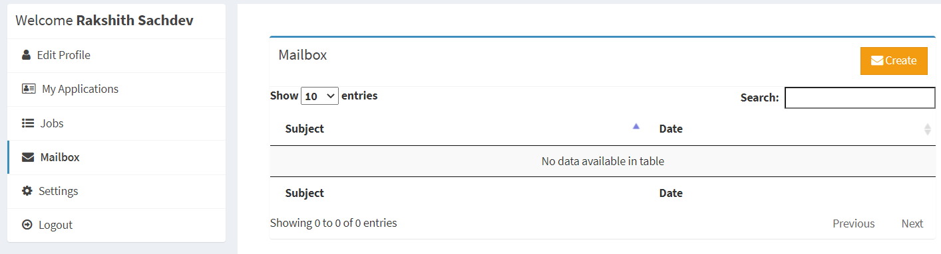

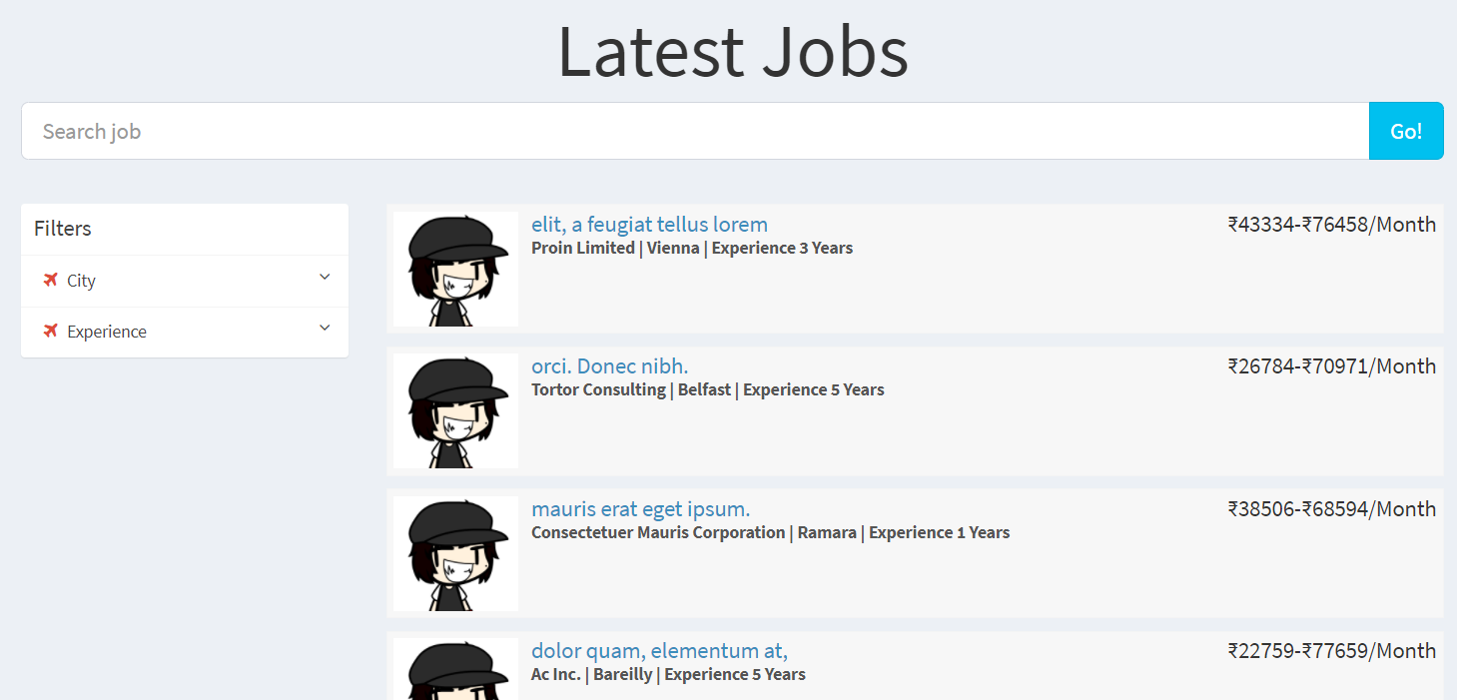

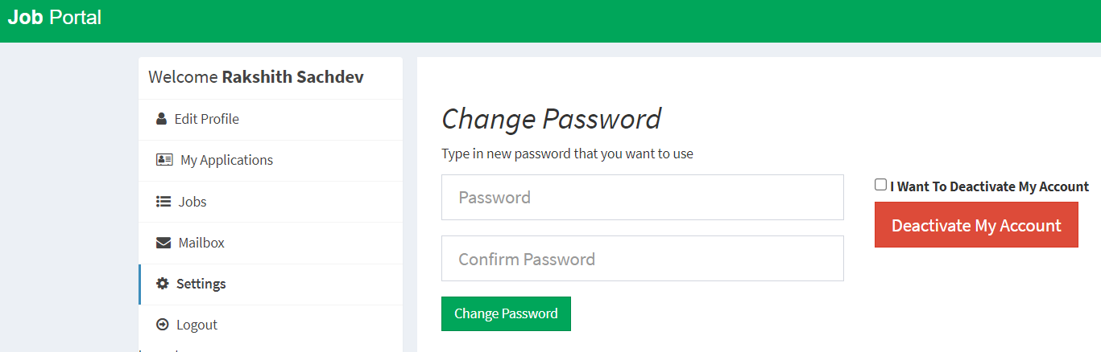

ML algorithm implementation and results

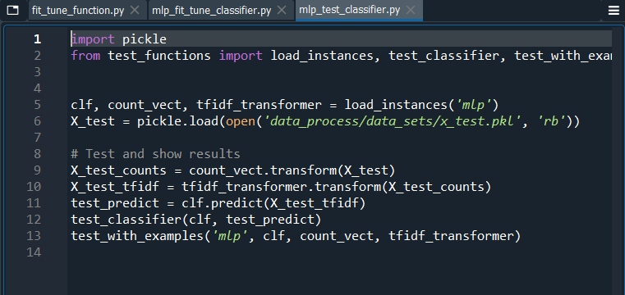

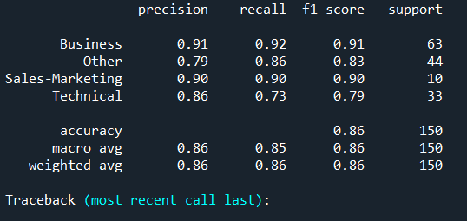

***SGD has better average than MLP. SGD uses SVM model, a good model for text classification. SGD/SVM has an accuracy of 96% and on the other hand MLP has a lesser accuracy of 86%.***

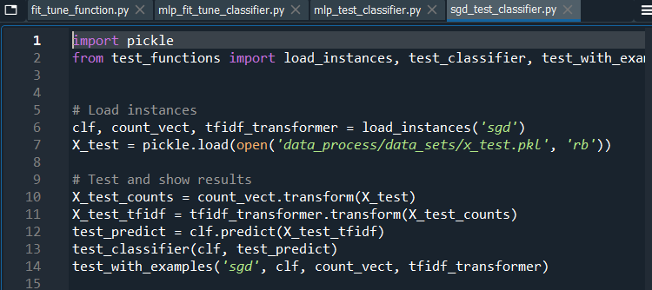

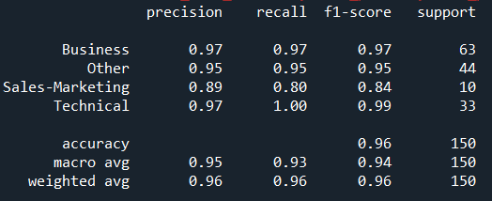

**Security feature output for our website:**

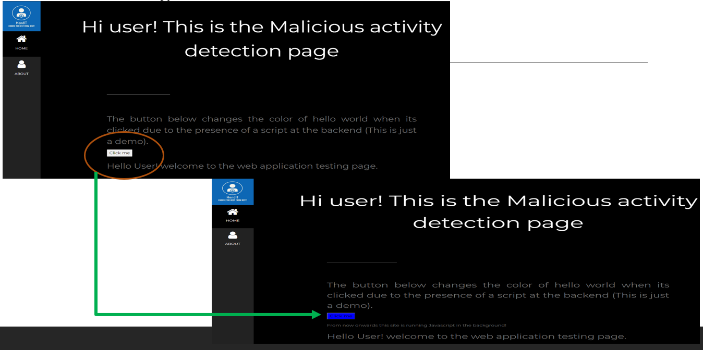

1. COST ANALYSIS

|  |  |  |
| --- | --- | --- |
| ***Cost factor/ revenue source*** | ***Cost/ revenue generated*** | ***Source for references*** |
| Permits and licenses | 5% of cost of the startup | source: <https://www.core77.com/posts/23366/Product-Licensing-101-So-Lets-Talk-Money>. |
| Incorporation fees | INR 6000 to 15000 | source: <https://taxguru.in/company-law/cost-private-limited-company-registration-india.html#:~:text=The%20Cost%20of%20Incorporation%20%2F%20Registration,the%20complexity%20of%20the%20task>. |
| Brochure and business card printing | INR 3500 Cost to print included | <https://99designs.com/blog/logo-branding/business-card-cost/>. |
| Down payment on rental property and Rent | Rs. 5000 per month | Found from parents and consulted family on this. (not to be done now due to pandemic times we will work from home). |
| Payment Gateway (To accept credit card, net banking or debit card online) | Rs. 25,000 (initiation fee)2 – 4% transaction fee (negotiable) per transaction. | <https://nextbigwhat.com/how-much-does-it-cost-to-startup-a-basic-ecommerce-company-in-india/>. |
| Improvements to [chosen location](https://articles.bplans.com/how-to-choose-a-business-location/) | INR 1 lakh one time | Consulted parents on this |
| Payroll and Utilities | Rs. 1-1.5 Lakhs per month for three to five employees.  Utilities: INR 30,000-40,000 | <https://nextbigwhat.com/how-much-does-it-cost-to-startup-a-basic-ecommerce-company-in-india/> |
| Marketing costs and advertisements | Do it yourself (poster, flyers, send email to friends) Typically zero. | <https://nextbigwhat.com/how-much-does-it-cost-to-startup-a-basic-ecommerce-company-in-india/> |
| Total starting costs |  | Maximum: Rs. 3,35,000 plus Rs. 1-1.5 Lakhs per month (building a team and hosting yourself)  Per annum cost of Startup= INR 15,03,500 +40,000.  **But we will initially work in pandemic time so work from home and considering that first we will bootstrap and only team members will work the cost will be= INR 40,000-50,000.** |
|  |  |  |
| Revenue generated commission from payments | 7.5% on customer transactions. | <https://paytm.com/offer/commission-details-page>. |
| Advertisement commission | the average [CPC for ads on Google’s display network](https://www.wordstream.com/cost-per-click) is INR 17-21 per click depending upon the resolution and type of ad | <https://support.google.com/adsense/answer/6242051?hl=en#zippy=%2Cdo-i-have-to-pay-to-use-adsense>.  <https://blog.taboola.com/how-much-do-websites-make-from-ads/#:~:text=According%20to%20WordStream%2C%20the%20average,earns%20that%20amount%20in%20revenue>.  <https://www.semrush.com/blog/what-is-google-adsense-and-how-to-make-money-with-it/>. |
| Subscription charges | INR 150 (gold member) and INR 250 (platinum member) per month per subscriber | Set by us seeing the standards and the competitors around us in the market right now. (revenue generated from premium subscription based on priority) it will be free for everyone for the first month and later a compulsory subscription. People paying for subscription (frequent users and payers) so they get incentives to join the membership as their transaction fee will be less. |
| Total revenue generated (let’s say 2000 subscribers) |  | 200*150 payment of subscription= INR 30,000 per month, 100*250=INR 25,000 (if we assume 100 gold and 50 platinum subscribers) total=INR 55000 per month +INR 24750 per month payment commission= INR 79750 per month  Total amt = INR 112150 per month after ad and payment commissions for 150 subscribers rest will also click for ads  Which gives **INR 13,45,800** per year revenue on just 450 users out of which only 300 are subscribers. |

**Table 3: Cost analysis and estimation for our project.**

* Logo design: INR 0 we can design ourselves.
* Website design: we designing ourselves as a team.
* If subscribers increase the profit percent depends on it.

1. RESULTS AND DISCUSSIONS

***SOCIAL BENEFITS OF ONLINE JOB PORTAL LIKE MENDIT:***

• Firstly, it promotes employers’ brand- The unskilled labour is not only looking for a job, but they also want to understand the work culture, their career growth, the workplace, the benefits that can be offered, and the kind of product and services they provide. They will also get whether they have a job security or not.

• Search for Endless Jobs- MendIT provide you an opportunity to search jobs from an array of categories which makes it easy for candidates, to filter out their options after browsing through them. It offers jobs from nearly all domains of the industry which is very much beneficial.

• Get regular job notifications- Apart from providing a platform to find jobs, MendIT also send regular alerts to candidates in case companies start recruitment drives. It is nearly impossible for candidates to track employer moves while conducting recruitments. The candidate is kept updated if the employer is interested by mails.

• Time and Cost to hire candidates reduces- One of the major benefits of using MendIT is that they are very affordable and cost-effective. Candidates can upload their resumes for free and search jobs across any field without having to pay any fee to the job portal. The loss of time by recruiters and even candidates will reduce to a great extent.

• Maintain Complete Confidentiality- Your job search history and profile is kept completely confidential in the database of MendIT which means you can conduct your job searches in a highly discreet manner without letting anyone to know about what you are up to. Furthermore, these job portals do not share your information anywhere and respect your privacy that makes them a safe bet.

ML algorithm implementation and results:

***SGD has better average than MLP. SGD uses SVM model, a good model for text classification. SGD/SVM has an accuracy of 96% and on the other hand MLP has a lesser accuracy of 86%.***

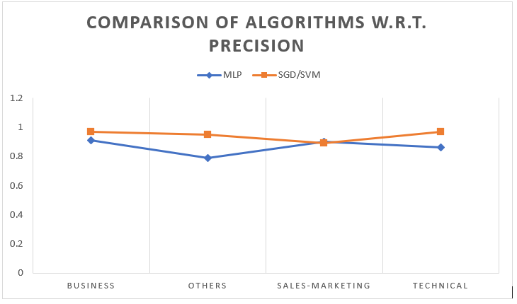

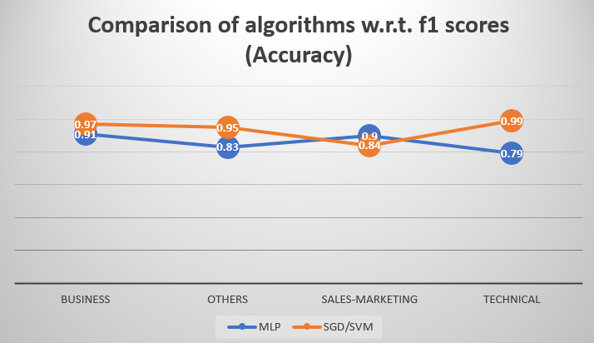

1. PROSPECTIVE CUSTOMERS AND FUTURE PLANS

Stakeholders are individuals who either care about or have vested interest in your project. They are the people who are actively involved with the work of the project or have something to either gain or lose as a result of the project. Stakeholders can affect or be affected by the organization's actions, objectives and policies. Some examples of key stakeholders are creditors, directors, employees, government (and its agencies), owners (shareholders), suppliers, unions, and the community from which the business draws its resources.

For our start-up, we will be recruiting:

● Skilled workers with relevant equipment

● Customers

● Payment processors

● Investors

● Map API providers

● Law services

● Security providers

● Accounting Segment

Employees:

Our Employees are a variety of people from different backgrounds with various amounts of experiences. We are looking for workers that are looking for long term employment. We feel that this is the best match for the success of our business. We have an inside motif our employees are happy, we and the customers are happy, with this type of work environment we believe it’s best for everyone. It is an absolute win, win situation.

Investors

● For our funding option we have angel investors and venture capitals.

● An angel investor is someone who puts their own finance into the growth of a small business at an early stage, also potentially contributing their advice and business experience.

● Venture capitals are professionally managed funds who invest in companies that have huge potential.

Customers

● Who don’t have direct contacts with unskilled workers

● Who are new in the locality

● Who need repairs in bad traveling situations

● Who want effective repairs within budget and based choice of workers.

**Technical Issues and demerits of our portal TO BE SOLVED IN FUTURE**

• Some candidates may not want to take the time or may not be confident enough with the security of an online application, especially if they are attempting to complete a lengthy application with a mobile device. There's always the possibility that our application system may operate slowly or lose information during the submission process.

• In many cases, candidates who see your job posting will be relying on our website to gain additional information about your company, its mission and method of operation. If our website is poorly designed or out of date, the candidate may not even bother to respond. There's also the possibility that the site won't have relevant information regarding the candidate's area of interest. You could even fall foul of discrimination legislation if your site isn't fully accessible.

• Finding a few quality sites to post the resume to is much better than canvasing dozens of poorly managed ones. Where to post your resume is a good way to ensure your privacy during a job hunt. We are keenly looking for a privacy seal like TRUSTe or BBB online.

• Scammers tend to use unsolicited e-mail supposedly from an employer, recruiter, or job board. Scammers crawl the Internet for personal information, in order to prey on job seekers.

• We will try to ensure the safety of our users, will get certification of security service companies like Secure Works, IBM, TrustWave and few others. Firewall management system needs to be put into action from these service providers to ensure uninterrupted and safe access of site by its users.

## References

[1] Jyoti V Gautam et al., “A Survey on Job Scheduling Algorithms in Big Data Processing”.

[2] Dorothea Calmels, “REVIEW ARTICLE The job sequencing and tool switching problem: state-of-the-art literature review, classification, and trends”, International Journal of Production Research, 2019 Vol. 57, Nos. 15–16, 5005–5025, <https://doi.org/10.1080/00207543.2018.1505057>.

[3] S. Clyde, Jianping Zhang and Chih-Chung Yao, "An object-oriented implementation of an adaptive classification of job openings," Proceedings the 11th Conference on Artificial Intelligence for Applications, Los Angeles, CA, USA, 1995, pp. 9-16, doi: 10.1109/CAIA.1995.378795.

[4] F. M. Javed Mehedi Shamrat, Z. Tasnim, P. Ghosh, A. Majumder and M. Z. Hasan, "Personalization of Job Circular Announcement to Applicants Using Decision Tree Classification Algorithm," 2020 IEEE International Conference for Innovation in Technology (INOCON), Bangluru, India, 2020, pp. 1-5, doi: 10.1109/INOCON50539.2020.9298253.

[5] L. Xu, J. Cao, Y. Wang, L. Yang and J. Li, "Bejo: Behavior Based Job Classification for Resource Consumption Prediction in the Cloud," 2014 IEEE 6th International Conference on Cloud Computing Technology and Science, Singapore, 2014, pp. 10-17, doi: 10.1109/CloudCom.2014.48.

[6]  Habiba, Sultana Umme; Islam, Md. Khairul; Tasnim, Farzana. In: 2021 2nd International Conference on Robotics, Electrical and Signal Processing **Techniques** (ICREST) Robotics, Electrical and Signal Processing **Techniques** (ICREST), 2021 2nd International Conference on. :543-546 Jan, 2021

[7] S. Deshmukh, J. V. Aghav and R. Chakravarthy, "Job Classification for MapReduce Scheduler in Heterogeneous Environment," 2013 International Conference on Cloud & Ubiquitous Computing & Emerging Technologies, Pune, India, 2013, pp. 26-29, doi: 10.1109/CUBE.2013.15.

[8] A. D. Hartanto, E. Utami, S. Adi and H. S. Hudnanto, "Job Seeker Profile Classification of Twitter Data Using the Naïve Bayes Classifier Algorithm Based on the DISC Method," 2019 4th International Conference on Information Technology, Information Systems and Electrical Engineering (ICITISEE), Yogyakarta, Indonesia, 2019, pp. 533-536, doi: 10.1109/ICITISEE48480.2019.9003963.

[9] Ikudo, Akina & Lane, Julia & Staudt, Joseph & Weinberg, Bruce. (2019). Occupational classifications: A machine learning approach. Journal of Economic and Social Measurement. 44. 1-31. 10.3233/JEM-190463.

[10] V. K. Sehgal, A. Jagtiani, M. Shah, A. Sharma, A. Jaiswal and D. Mehta, "Job Portal - A Web Application for Geographically Distributed Multiple Clients," 2013 1st International Conference on Artificial Intelligence, Modelling and Simulation, Kota Kinabalu, Malaysia, 2013, pp. 199-204, doi: 10.1109/AIMS.2013.38.

[11] C. Wu, W. Chang, W. Tsai, F. Lin, C. Lee and C. Yang, "Multi-node Big Data VM Platform and Job Submission Portlet," 2017 5th Intl Conf on Applied Computing and Information Technology/4th Intl Conf on Computational Science/Intelligence and Applied Informatics/2nd Intl Conf on Big Data, Cloud Computing, Data Science (ACIT-CSII-BCD), Hamamatsu, Japan, 2017, pp. 228-233, doi: 10.1109/ACIT-CSII-BCD.2017.72.

[12] Dr. Umesh B. Patwardhan, “Perception of Job Seekers Towards Monster.Com as an Online Job Seeking Avenue”, in Journal for Contemporary Research in Management, 2016. Available: [https://pdfs.semanticscholar.org/d34b/81bb385c808f2f016c6e5d6aac 695e2b185c.pdf](https://pdfs.semanticscholar.org/d34b/81bb385c808f2f016c6e5d6aac%20695e2b185c.pdf).

[13] V. Yadav, U. Gewali, S. Khatri, S. R. Rauniyar and A. Shakya, "Smart Job Recruitment Automation: Bridging Industry and University," 2019 Artificial Intelligence for Transforming Business and Society (AITB), Kathmandu, Nepal, 2019, pp. 1-6, doi: 10.1109/AITB48515.2019.8947445.

[14] O. Pektor, B. Walek and I. Martinik, "A Data Mining Approach for Finding Similar Job Positions to Upgrade a Job Position in a System for Evaluating Competencies," 2020 21th International Carpathian Control Conference (ICCC), High Tatras, Slovakia, 2020, pp. 1-5, doi: 10.1109/ICCC49264.2020.9257298.

[15] Miroslav Beblavý et al., “The surprisingly exclusive nature of medium- and low-skilled jobs Evidence from a Slovak job portal”, https://www.emerald.com/insight/publication/issn/0048-3486.

[16] I. Makdoun, G. Mezzour, K. M. Carley and I. Kassou, "Analyzing the Needs of the Automotive Job Market in Morocco," 2018 13th International Conference on Computer Science & Education (ICCSE), Colombo, 2018, pp. 1-6, doi: 10.1109/ICCSE.2018.8468854.

[17] Shanti Dahal et al., “Mapping of Public Health Jobs in India—Where Can the Public Health Graduates Be Employed?”, Journal of Health Management 20(1) 73–83 © 2018 Indian Institute of Health Management Research SAGE Publications sagepub.in/home.nav DOI: 10.1177/0972063417747725.

[18] Uma Pavan Kumar Kethavarapu and Dr.S.Saraswathi, “Concept Based Dynamic Ontology Creation for Job Recommendation System”, International Conference on Computational Modeling and Security (CMS 2016).

1. SCHEDULES AND ROADMAP THROUGH GANTT CHART

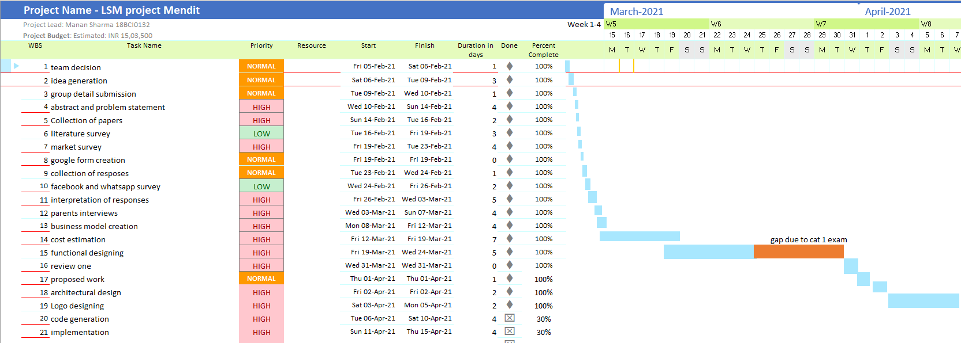



**Figure 17: Gantt chart and activity roadmap for first phase.**

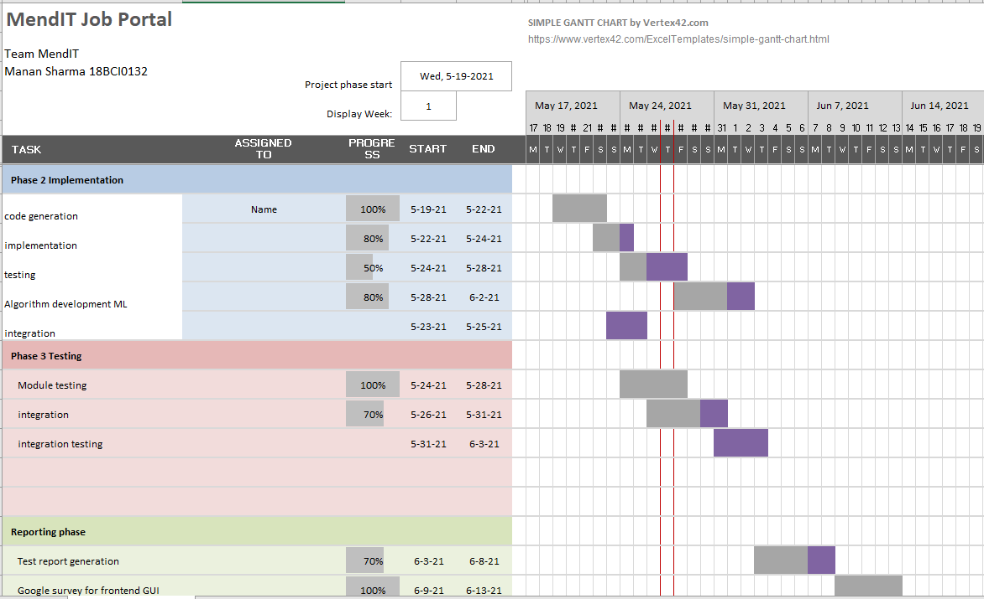

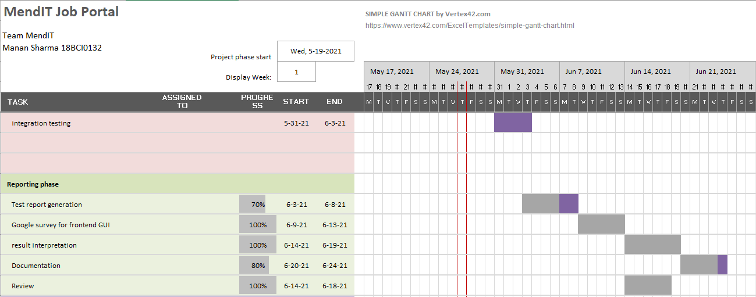

**Figure 18: Gantt chart and roadmap for phase 2 of project.**

Thank you

Contribution by the following team members-

***Contribution of team members:***

|  |  |
| --- | --- |
| **Manan (18BCI0132)** | 1. Digital marketing survey on Facebook and WhatsApp. 2. Contributed and analyzed 4 papers in literature survey. 3. Cost estimation along with hrithik. 4. Security feature implementation. 5. Designed the backend schemas. 6. Did the digital marketing of logos on Facebook, WhatsApp and LinkedIn. 7. Designed the use case model and requirements specifications |
| **Ayush (18BCE2305)** | 1. Digital marketing survey on Google forms. 2. Analyzed 4 papers for survey. 3. Analyzed the competitors of our product. 4. Documented the MOM’s and evidences for the same. 5. Designed the logos for our company and website. 6. Designed the home page and job availability module’s frontend. 7. Integration of all modules. |
| **Rakshith (18BCI0109)** | 1. Architecture design of our system. 2. Contributed family and friends’ discussions to survey. 3. Analyzed 4 papers in survey. 4. Implemented the ML algorithm (MLP classifier). 5. Designed the terms and conditions and policies page for the portal. 6. Backend development and created the database on the basis of the schemas designed. |
| **Hrithik (18BCE2154)** | 1. Analyzed 4 papers in survey and documented the survey. 2. Cost estimation. 3. Defined the Gantt chart and road map for the project and updated it regularly. 4. Implemented the ML algorithm with Rakshith and both of us analyzed it too (I did SGD/SVM classifier). 5. Helped in integration of all modules with Ayush. 6. Designed about page, customer login and all customer related pages. |
| **Rohan (18BCI0247)** | 1. Contributed family and friends’ discussions to our survey. 2. Analyzed 4 papers in survey. 3. Defined the Business model. 4. Surveyed for the selection of logos and interpreted the responses on Google forms. 5. I Did the GUI usability testing survey and collected the responses using Google forms. 6. Generated the module testing report. 7. Designed company and vendor related pages and company signup page. |

**Table 4: Contribution of individuals.**